 | weaving the rainbow
 | 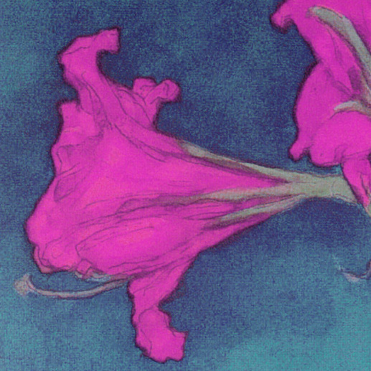 | Philosophy will clip an angel’s wings,  Conquer all mysteries by rule and line,  Empty the haunted air and gnomed mine,  Unweave a rainbow  John Keats, 1819
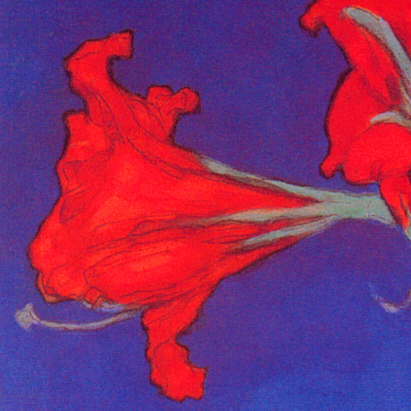 | 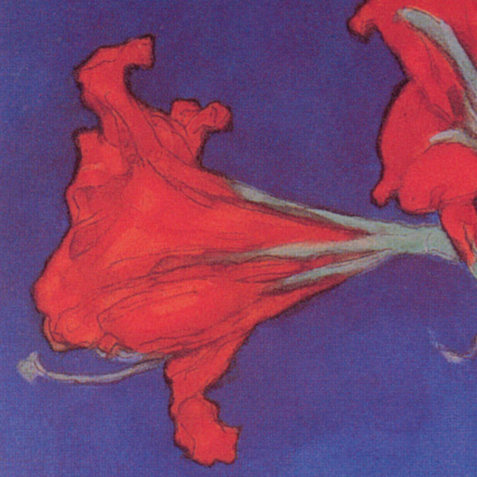 | 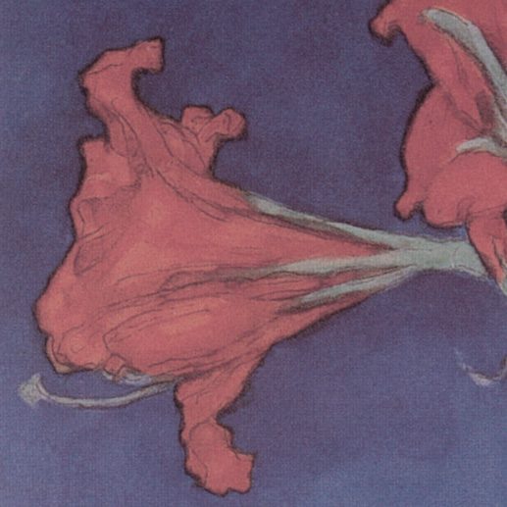 | 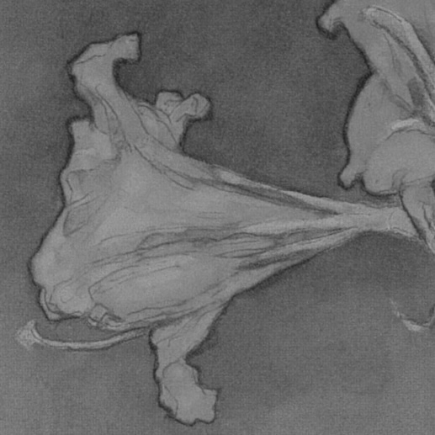
 | 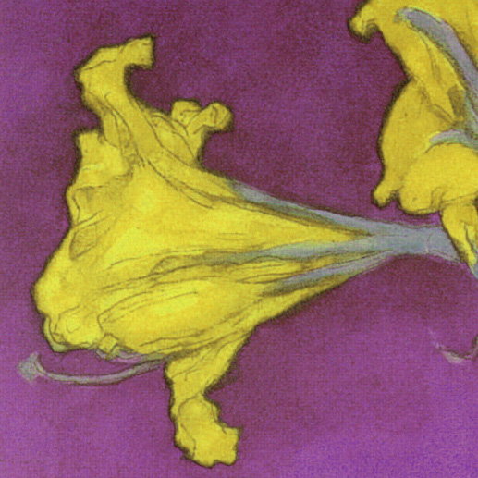 | Sally Semple  University of Strathclyde
 | 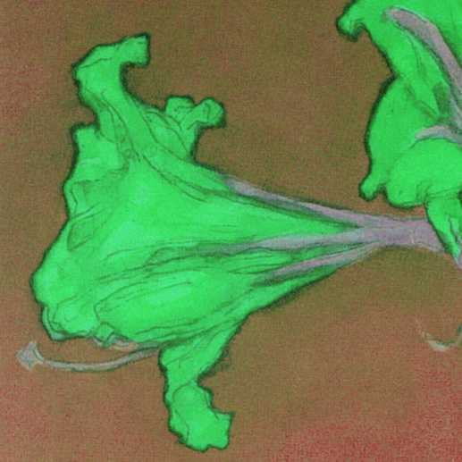
 | 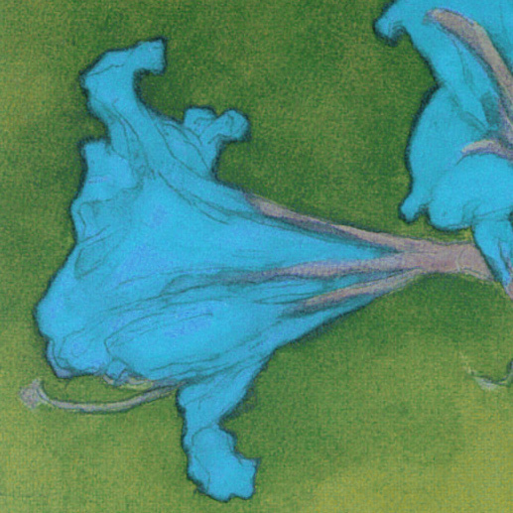
weaving the rainbow
a rule-based method for colour design

Sally Semple
Building Design Engineering
Department of Architecture and Building Science
Faculty of Engineering
University of Strathclyde
August 2005

BEng (Building Design Engineering)
Honours studies (year 4) 2004-2005
DISSERTATION (BDE) AB401 (3 credits)

Declaration

I hereby declare that this dissertation is my own work, contains no unacknowledged text and has not been submitted in any previous context. All quotations have been distinguished by quotation marks and all sources of information, text, illustrations, etc. have been specifically acknowledged.

I accept that if, having signed this declaration, my work should be found at Examination to contain deliberate plagiarism the work will Fail and I will be liable to face University discipline procedures.

Name: Sally Semple

Signed:

Date: 19th August 2005

contents

1 illustrations 1
2 glossary 2
3 introduction 3
4 colour 4
4.1 colour systems 5
4.1.1 history 5
4.1.2 contemporary systems 6
4.2 colour differences 9
5 colour theory 10
5.1 harmony 10
5.2 exterior colours 12
5.2.1 materials 12
5.2.2 light 13
5.2.3 context 15
5.2.4 culture 16
6 colour schemes 17
6.1 Burano 17
6.1.1 assessment 18
6.2 Turin 19
6.2.1 assessment 20
6.3 database 21
6.3.1 assessment 22
6.4 Chateau-Double 22
6.4.1 assessment 23
7 colour combinations application 25
7.1 introduction 25
7.2 development 26
7.2.1 colour systems 26
7.2.2 context 28
7.2.3 colour preferences 28
7.2.4 harmony 29
7.3 examples 30
7.3.1 design for contrast 30
7.3.2 design for integration 33
7.3.3 design for harmony 36
7.4 assessment and development 39
8 conclusions 40
9 bibliography 41

Appendix A colour combinations application (on CD)
Appendix B colour combinations application code

illustrations
all illustrations are by the author unless otherwise stated

front cover hue and saturation transformations of a fragment from Red Amaryllis with Blue Background, Piet Mondrian, 1907, Museum of Modern Art, New York

Figure 4-a: Newton’s spectrum 5
Figure 4-b: Runge’s colour sphere 5
Figure 4-c: Chromacity diagram 7
Figure 4-d: HSB colour wheel 8
Figure 4-e: Munsell colour wheel 8
Figure 5-a: complementary colours 10
Figure 5-b: non-complementary colours 10
Figure 5-c: light study 13
Figure 5-d: spectral power distribution of daylight 14
Figure 5-e: Central Park 15
Figure 6-a: Burano 18
Figure 6-b: Turin 20
Figure 6-c: Chateau Double apartments 23
Figure 7-a: Great Western Road, Glasgow 25
Figure 7-b: examples of colour combination outputs 26
Figure 7-c: varying saturation and value 27
Figure 7-d: initial palette for a contrasting design 30
Figure 7-e: contrasting colour combination 32
Figure 7-f: initial palette for an integrated design 33
Figure 7-g: integrated colour combination 35
Figure 7-h: initial palette for a harmony design 36
Figure 7-i: harmonious colour combination 38

glossary

BRE Building Research Establishment
CCT correlated colour temperature
CIE Commission Internationale d’Eclairage
cmy cyan, magenta, yellow
cmyk cyan, magenta, yellow, black
HSB hue, saturation, brightness
HSL hue, saturation, lightness
HSV hue, saturation, value
Hz hertz
ICC International Color Consortium
L*ab lightness, a, b
L*chº lightness, chroma, hue
NCS Natural Colour System
nm nanometres
RGB red, green, blue
spd spectral power distribution
XYZ tristimulus colour specification system

introduction
“And the hanging for the gate of the court was needlework, of blue and purple and scarlet and fine twined linen... ”
Exodus 38.16

The design of colour schemes has a long history with local materials, changing fashions, colour theory, new technology and divine ordinance all playing their part. Today we have the ability to produce and combine thousands of exterior colours yet much of the built environment remains monochrome.

This dissertation examines the nature of exterior colour and investigates the possibility of improving the choices available for colour design through the application of a rule-based system.

The colour experience, colour order systems and transformations within these systems are described. Current colour theory and its application to exterior colour is summarised and used to propose rules for colour combinations. A variety of colour scheme designs are examined and assessed against these rules which are modified accordingly. The rules are used as the basis for an application which produces suggested colour combinations. The resulting colour schemes are demonstrated for an existing domestic facade in Glasgow with a final assessment of the possibilities for rule-based systems as a design tool.

colour
“By convention there is colour, by convention sweetness and bitterness, but in reality there are atoms and space”
Democritus (460BC – 370BC) Fragment 125

The experience of colour is the reaction of our minds to the stimulation of our retina by light (Wyszecki and Stiles, 2000). Different colours are associated with different materials but it is not a material property (Grandis, 1986). It is difficult, if not impossible, to get consensus between different observers (or even the same observer under different conditions) on which colours are identical and which are different (Wyszecki and Stiles, 2000) which has limited the attempts to create accurate perceptual metrics for colour.

Although “as yet there is no scientific explanation of the colour vision process” (Kuenhi, 2005) there is broad agreement that most people respond to stimuli along three axes which can be described as dark/light, blue/yellow and red/green. However our perceptions and descriptions of colour more often use the three stimuli described as hue, value (lightness, reflectance or luminance) and saturation (colourfulness or chroma) (Birren, 1969), ie:

hue – for example “blue”, “green” or “scarlet”
value – for example “dark” or “light”
saturation – the absence of grey, for example “dull” or “strong”

colour systems
Colour systems or colour orders are used to identify individual colours and place them in a relationship with all other colours. The development of languages points to the idea that, within all cultures, colours are recognised and named in the same order: light/dark, red, green, blue, yellow and brown (Berlin and Kay, 1969). Beyond this the most significant developments in arranging colours within Western culture are summarised here.

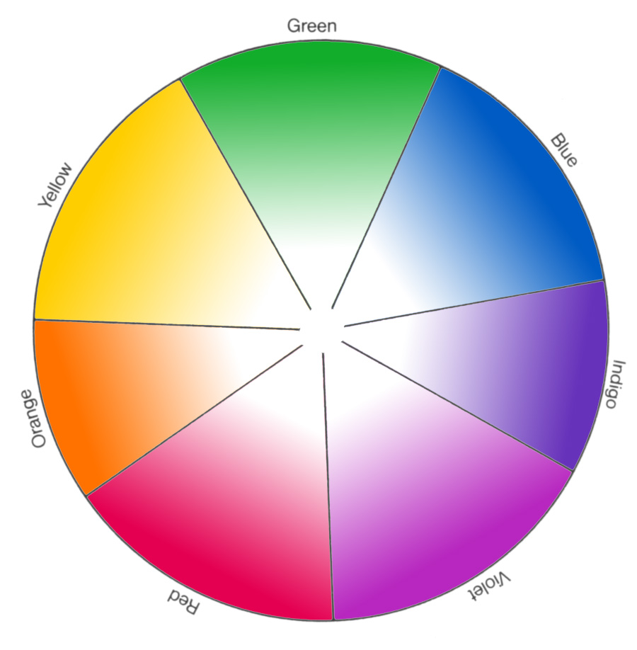  Figure 4-a: Harald Küppers. Newton’s spectrum (from: Color, 1973) | 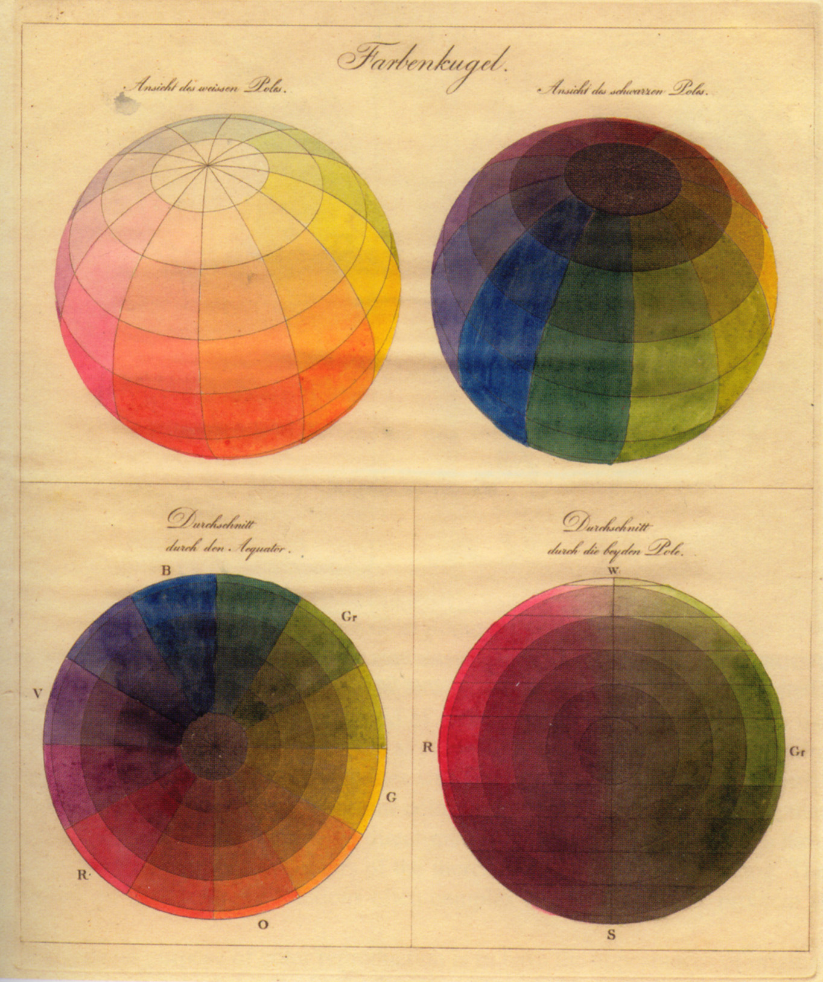  Figure 4-b: Otto Runge, Runge’s colour sphere (from: Color, 2005)

history
In 1704 Isaac Newton published his treatise Opticks (Duttman et al., 1981) which described splitting white light into a spectrum of seven discernable colours: red, orange, yellow, green, blue, indigo and violet. He joined the violet and red ends of the spectrum to create a circle as shown above. At this time there was also a practical understanding, amongst painters and dyers, that there were three fundamental hues: yellow, red and blue, from which all other hues could be created (Kuenhi, 2005).

In 1810 Philipp Otto Runge proposed a colour system – a sphere - in three dimensions as shown. This used the three primary colours of painters and included white and black to form the sphere’s poles. His system was not designed, as previous systems had been, to help with colour mixing (for example, mixing red and green paint, would not produce the neutral grey at the centre of his sphere). It was intended to bring order to the totality of colours. Runge’s system ordered colours within a three-dimensional shape defined by three attributes: hue, value and saturation.

In 1905 the physiologist Ewald Hering published his “Principles on the Theory of Sensitivity to Light” which used four basic hues as opponents of each other: red/green and blue/yellow with the addition of white/black (Agoston, 1987). He argued that each colour sensation could be seen as a mixture of these six basic sensations. He arranged the hues into a circle with blue opposite yellow and red opposite green which he described as a “Natural system of colour sensations”.

The idea of primary or basic colours which can be used as absolutes to define all other colours is a powerful one and is important in terms of defining the proportions of each system but there has been little agreement over the definition of a primary colour: Newton used seven basic hues; Runge used three; Hering used four and Munsell used five. Contemporary colour theory uses the philosophical idea of ‘unique hues’ which cannot be described by any name other than their own. These are: yellow, red blue and green (Kuenhi, 2005).

contemporary systems
Contemporary colour systems use three stimuli to locate each individual colour within a three-dimensional space. The systems used today can be divided into three types: physical, technical and perceptual. This reflects the paradox of colour which exists as a perception, triggered by physical stimuli which are produced in turn by technical means.

Physical models describe individual colours (when viewed in controlled circumstances) in terms of established physical constants. They include the XYZ and L*ab systems developed by the CIE. These systems can accurately identify individual colours in a numerical form but have a disproportionately large number of colours within the green region relative to our perception of colours.

Technical models are linked to the mechanisms used to trigger colours and include RGB, used for colour monitors and other luminous sources, and CMYK used for four colour printing. The RGB model (based on varying proportions of red, green and blue light) has the same characteristics as CIE’s XYZ system in that it produces a disproportionate number of colours in the green region. The CMYK system uses four colours: cyan, magenta, yellow and black to produce colours which reflect (rather than generate) light. The translation between the RGB and CMYK systems is monitored and controlled by the International Color Consortium. Neither RGB nor CMYK are able to represent all the colours which we are able to perceive.

Perceptual colour systems are based on what we see as equal steps between colours. They use the three intuitive stimuli of hue, saturation and value to specify and arrange colours and include the Munsell Colour System (Munsell, 1975), the Natural Colour System (Agoston, 1987) and databases such as Pantone. The Munsell system uses five hues (red, yellow, green, blue and purple) arranged round a grey axis. This system incorporates the inconsistencies of the colour experience so that different hues have different maximum saturations (ie the brightest possible red is brighter than the brightest possible blue) and also that different hues reach their maximum saturations at different values (ie the brightest possible yellow is lighter than the brightest possible blue). The boundaries of the system are flexible and have expanded since 1905 to incorporate, for example, the fluorescent colours which are now able to reproduce. The Natural Colour System is a development of Hering’s work which uses descriptions of colours in terms of the four unique hues, white and black to locate individual colours within a 3-dimensional space. Systems such as pantone use carefully controlled colour samples arranged by hue and a combination of saturation and value in formats such as sample books (often produced in special editions with limited colours for specific applications such as architecture) which can be cross-referenced with RGB or CMYK colours.

There are some systems which combine the metric specification of XYZ or RGB with the intuitive control of systems such as Munsell. The CIE L*ab system has been further adapted to produce L*chº which uses three stimuli (lightness, chroma and hue) to identify colours. The L*chº system has been developed to try and ensure that, for example, colours with the same value of L will appear equally light when viewed in the same conditions. However the translation between the physical XYZ (or RGB) system and the perceptual L*chº (or the Munsell system) involves extensive mathematical transformations.

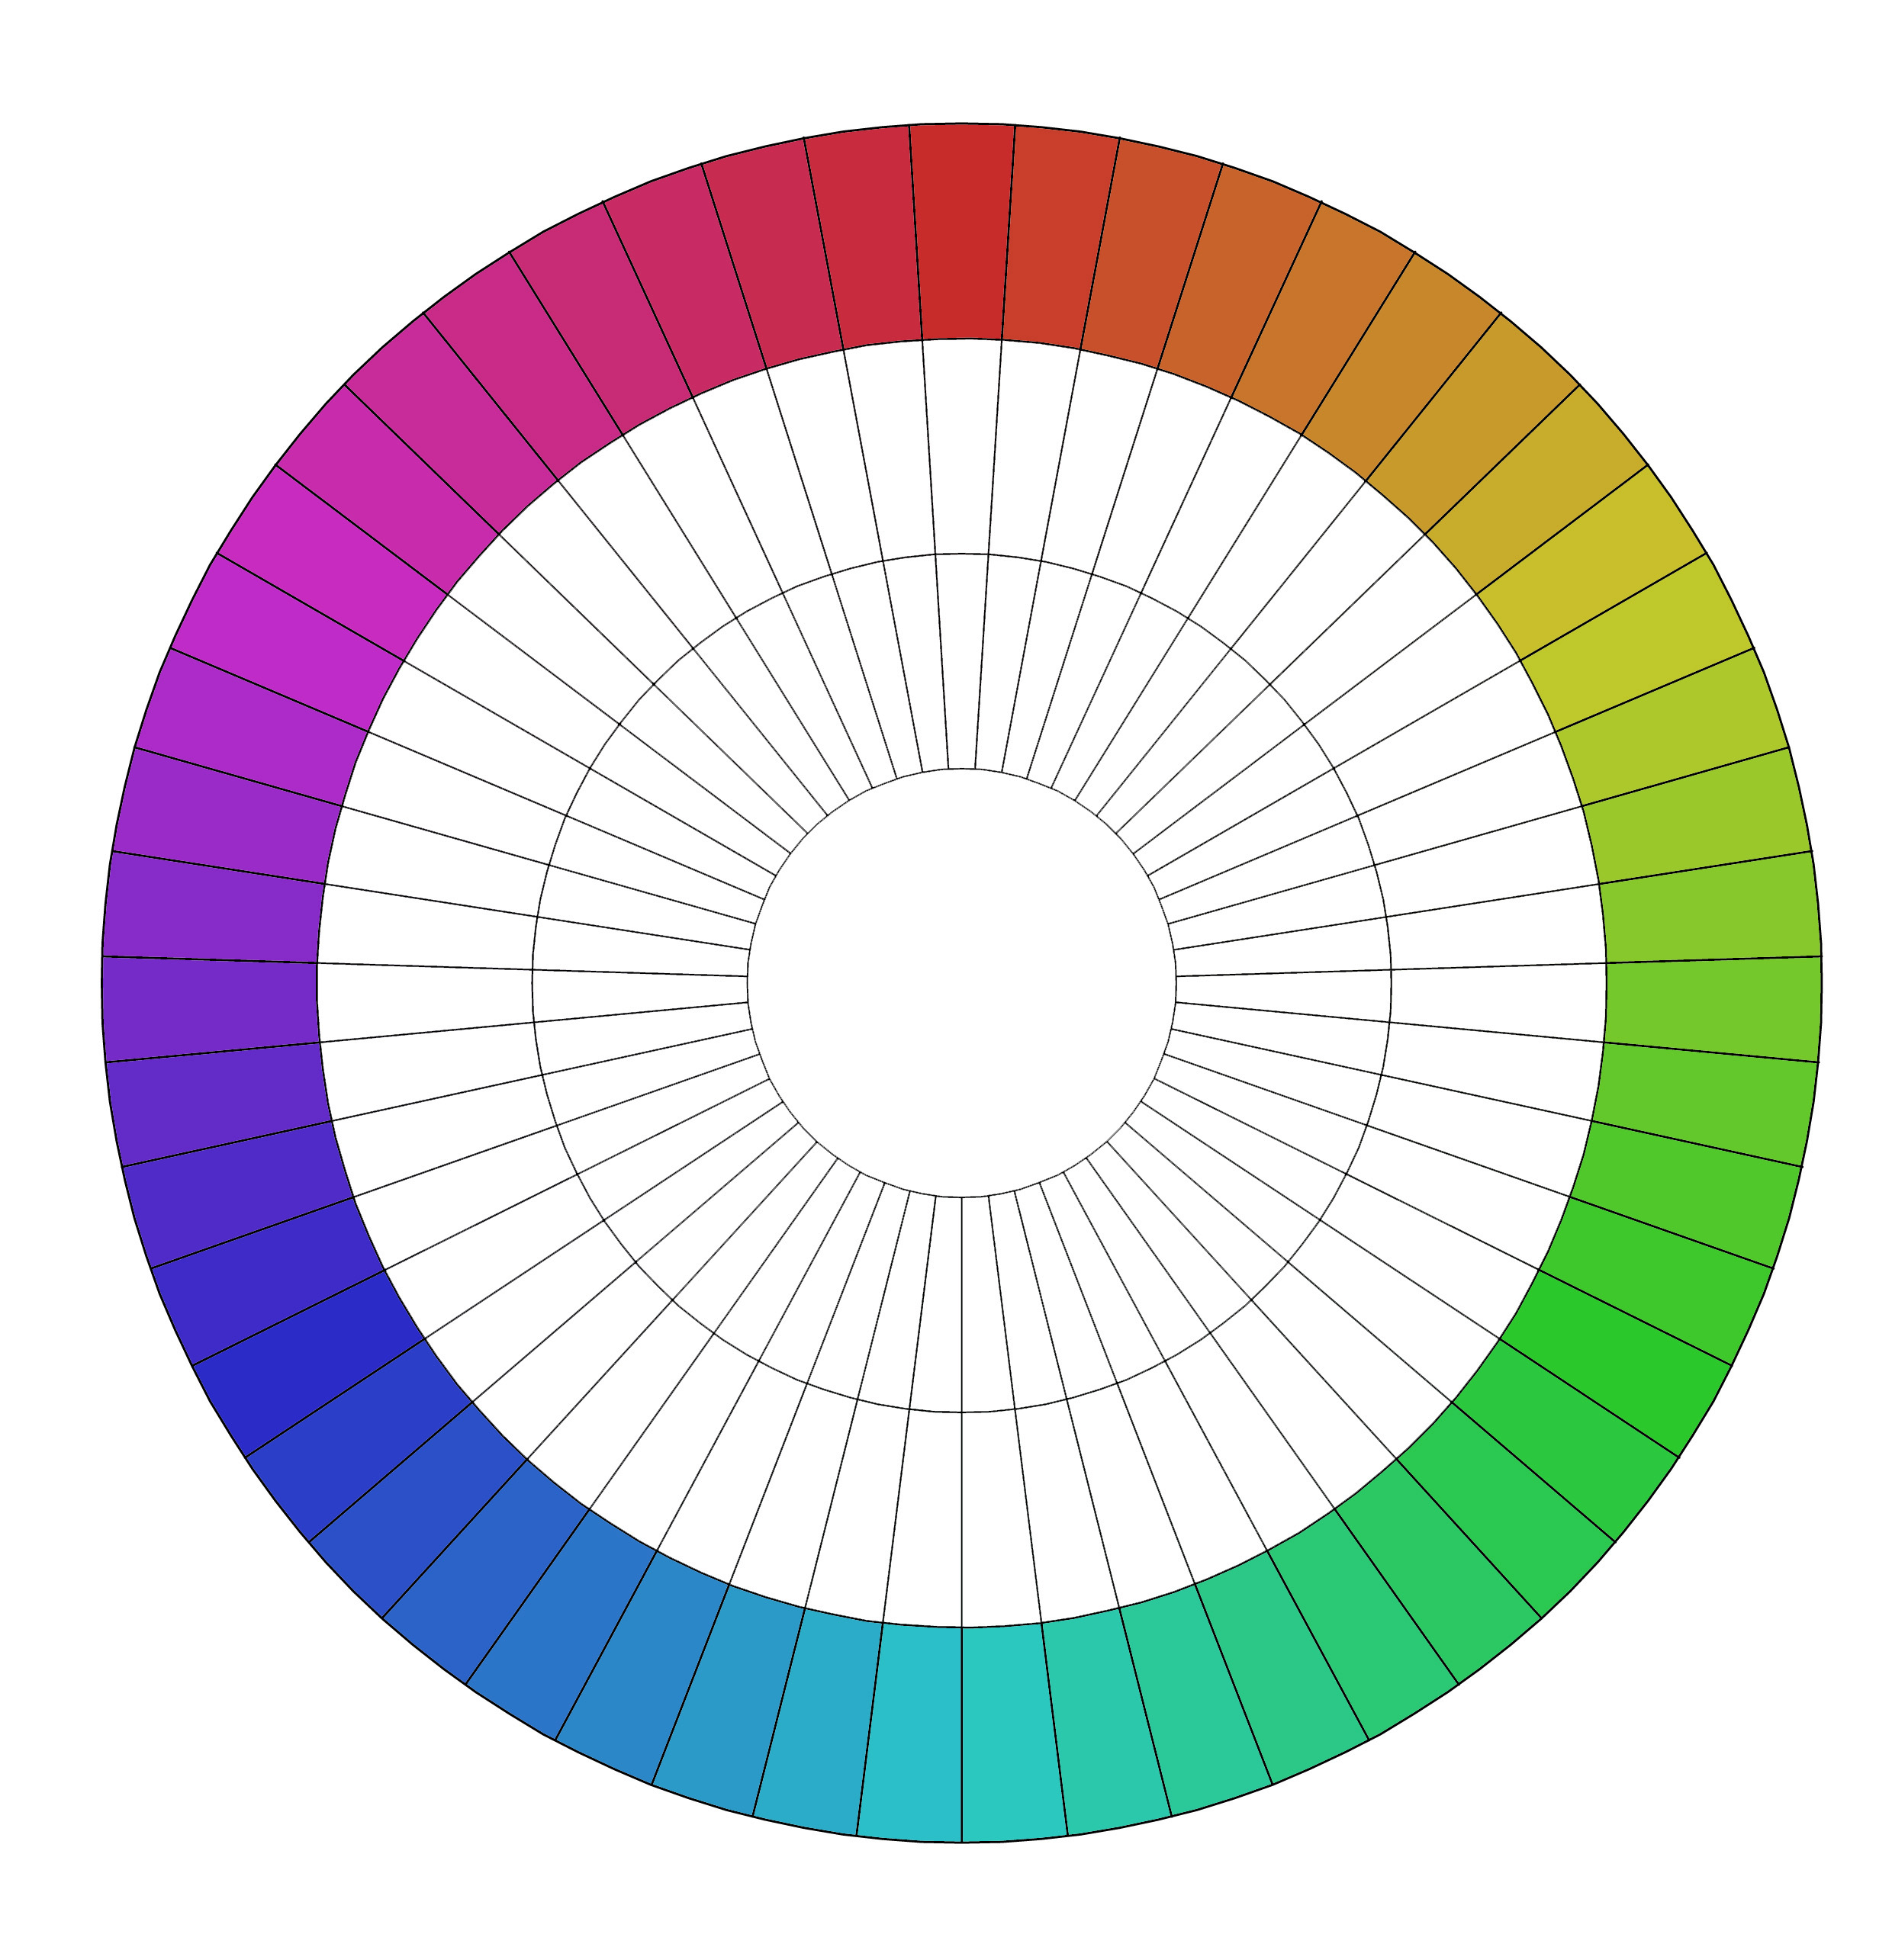  Figure 4-c: HSB colour wheel | 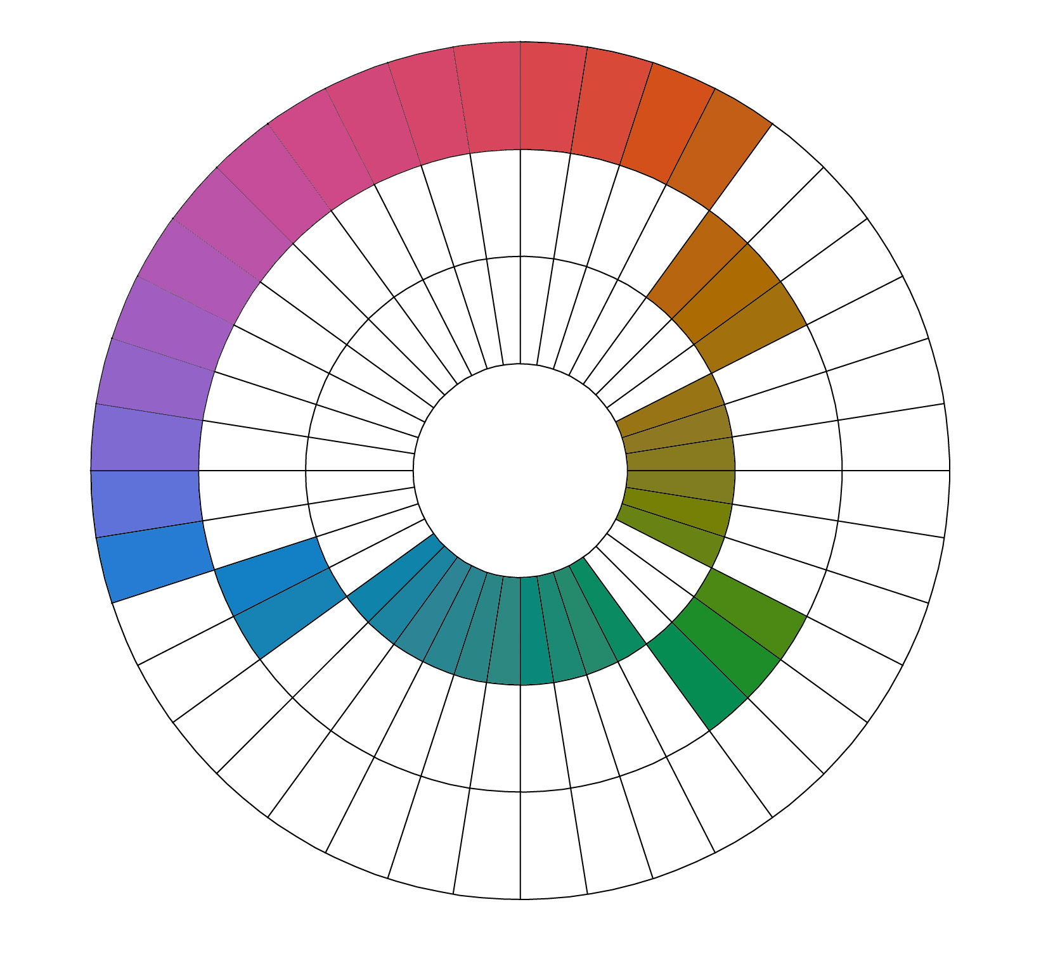  Figure 4-d: Munsell colour wheel

Most computer applications which use colour also use some version of an HSV system (sometimes called HSL or HSB) which use different ranges but which are simple translations from the RGB system. These HSV systems do not produce consistent results so that, for example, the wheel on the left above shows the results for the HSB system used by Photoshop with hues from 0º to 360º in 7.2º steps (this same example could equally apply to the HSL system used by Windows with hues from 0 to 255 in steps of 5) and saturation and brightness of 78%. There are obvious variations in both the lightness and saturation of different hues with yellow appearing far lighter than blue. This wheel can be compared with that for Munsell hue steps of 2.5 (using a value of 5 and a saturation of 14), shown on the right. The Munsell wheel provides consistently light examples and consistent saturation although (for the indented colours) the maximum saturation available at that value is less then 14. the differences between the RGB-based HSL systems and Munsell can also be demonstrated in the number of steps between the unique hues of red, green and blue.

hue sector | HSL | Munsell
red to green | 33 | 53
green to blue | 33 | 26
blue to red | 33 | 31

colour differences
The colour systems above all provide ways of transforming colours along the intuitive stimuli of hue, saturation and value. The following examples demonstrate the translation of an initial colour red (viewed in daylight) within the Munsell system.

 | Munsell  hue: 6R  value: 6  chroma: 7 | XYZ  X: 36.49  Y: 30.00  Z: 21.63 | RGB  Red: 204/255  Green: 127/255  Blue: 120/255 | HSL  hue: 3/255  saturation: 115/255  luminance: 162/255 | CMYK  cyan: 19  magenta: 50  yellow: 52

Adjusting the hue to produce a diametrically-opposite colour produces a blue/green.

 | Munsell  hue: 7.5BG  value: 6  chroma: 7 | XYZ  X: 20.73  Y: 30.12  Z: 39.67 | RGB  Red: 30/255  Green: 164/255  Blue: 163/255 | HSL  hue: 127/255  saturation: 176/255  luminance: 97/255 | CMYK  cyan: 72  magenta: 20  yellow: 20  black: 15

Increasing the saturation produces a brighter red.

 | Munsell  hue: 6R  value: 6  chroma: 14 | XYZ  X: 48.09  Y: 30.05  Z: 13.28 | RGB  Red: 253/255  Green: 96/255  Blue: 87/255 | HSL  hue: 2/255  saturation: 249/255  luminance: 170/255 | CMYK  cyan: 0  magenta: 62  yellow: 65

Increasing the lightness produces a pink.

 | Munsell  hue: 6R  value: 7.5  chroma: 7 | XYZ  X: 59.17  Y: 50.6  Z: 38.52 | RGB  Red: 249/255  Green: 166/255  Blue: 156/255 | HSL  hue: 5/255  saturation: 226/255  luminance: 203/255 | CMYK  cyan: 2  magenta: 34  yellow: 38

colour theory
“It is clear that the harmony of colour must rest only on the principle of touching the human soul”
Kadinsky, 1912

harmony
The development of theories of colour harmony has obvious links to music and Newton’s original seven colours were explicitly linked to the musical scale. Since then theories of harmony have included ideas of character assigned to colours by Goethe (Matthaei, 1971); ideals of purity and balance in the work of the De Stijl movement (Gage, 1993) and geometric transformations in arrangements by Itten (Itten, 1987). In this dissertation we are looking for theories of harmony that can be expressed numerically and some of the key pointers to this are discussed below.

  Figure 5-e: complementary colours (the yellow background enhances the blue square) |   Figure 5-f: non-complementary colours (the brown squares appears tainted by the background colours)

In 1852 Helmholtz demonstrated that for every spectral stimuli there is a complementary stimuli which will produce white light if they are mixed (Wyszecki and Stiles, 2000). This was followed by the work of Michel Chevreul, on behalf of textile dyers, who proposed the idea of simultaneous contrast where “two adjacent colours, when seen by the eye, will appear as dissimilar as possible” he also suggested that complementary colours will brighten each other and non-complementary colours would “contaminate” each other (Gage, 1993: 173). These ideas are demonstrated in examples of the teachings of Josef Albers and reproductions of his students’ work in figures 6 and 7 (Albers, 1971). The idea of harmonious colours was further developed by Bezold (Von Bezold, 1876) who proposed the idea of three different relationships (nearby, complementary and near-complementary) within the three components (hue saturation and value) of colour.

However the idea that “we should be abandoning the aesthetic concept of harmony as restrictive” (Grandis, 1986: 151) has led to the current situation where rules on colour harmony “vary widely and lack a solid basis” (Kuenhi, 2005: 167) and the only generally accepted definitions of harmony such as Judd and Wyszecki’s 1975 proposition that “Colour harmony correlates colour combinations with pleasant feelings” are too general to reproduce numerically. However, as Kuenhi points out, the lack of a general theory for harmony does not prevent us from developing our own rules, applicable to our time, place and situation and Maggie Toy has also considered that “perhaps it is necessary to have strict rules for the application of color in architecture.”(Linton, 1999: 5)

A starting point is the broad agreement that harmony implies a clear-cut unambiguous relationship between colours (Gloag and Gold, 1978) and the attempt by Moon and Spencer (1944) to define these relationships. They proposed a numerical synthesis of colour harmony based on the theories of Chevreul, Goethe, Bezold and Munsell. They explicitly ignored the effects of adaptation of the eye and varying areas of colour and, although they suggested that some harmonies may be better than others, they refrained from attempting to rate them. Their rules are based on a three-dimensional colour space which is cross-referenced to Munsell and expressed below:

 | variation in value only | variation in saturation only | variation in hue only
pleasing intervals
identity | from zero to a just noticeable difference | from zero to a just noticeable difference | from zero to a just noticeable difference
similarity | from 0.5 to 1.5 | from 3 to 5 | from 7 to 12 steps
contrast | from 2.5 to 10 | 7 or over | from 28 to 50 steps
displeasing intervals
1st ambiguity | from a just noticeable difference to 0.5 | from a just noticeable difference to 3 | from a just noticeable difference to 7
2nd ambiguity | from 1.5 to 2.5 | from 5 to 7 | from 12 to 28 steps
glare | more than 10

These variations in hue defined above were used by the BRE as part of their recommendations for exterior colour coordination (Gloag and Gold, 1978) and they have been assessed against existing colour designs to check the possibility of using them for the generation of new colour harmonies.

exterior colours
Although the idea of dividing the world into distinct regions, each with their own palette of colours derived from the land and reflecting the inhabitants has been strongly suggested by the work of JP Lenclos (Lenclos and Lenclos, 2004) it is not confirmed by the research of AC Hardy in the UK where “apart from coastal and moorland areas, it was impossible – due to the variety of building materials – to divide the British countryside into zones of buildings of similar colour” (Porter, 1982: 48). Although Hardy’s work did not distinguish distinct hue areas in the UK it did find that exterior colours had reflectances in the broad range of 12% (eg roof slates) to 56% (eg white emulsion on blockwork). He did not consider the saturation of exterior colours significant because of the continually changing nature of this quality with seasons, daylight and distance. Hardy also suggested that colours for the built environment should contrast with the existing context to avoid ambiguity.

materials
The development in the 19th century of light-fast synthetic pigments has now led to enormous variety in the colours available for external use. Dulux paints in the UK now list 1,169 individual colours available for exterior paints (Dulux, 2005). The availability of strong, reliable exterior colours has had a dramatic effect on some urban landscapes.

“Clonakilty today is a picture-book Irish town. A few years ago all the houses and shops on the long, narrow main street were repainted in the reds, greens, yellows and blues that can be seen on the new generation of tourist postcards. These bright colours are the new vernacular in a country where once everything was grey.”
Pete McCarthy, 2002

The gamut of colours available for exterior surfaces is still expanding as both pigments develop and materials such as luminescent sources, metallic finishes and film colours are adapted for external use. For the purposes of this dissertation we have limited the discussion of colours to those currently reproduced through CMYK.

light
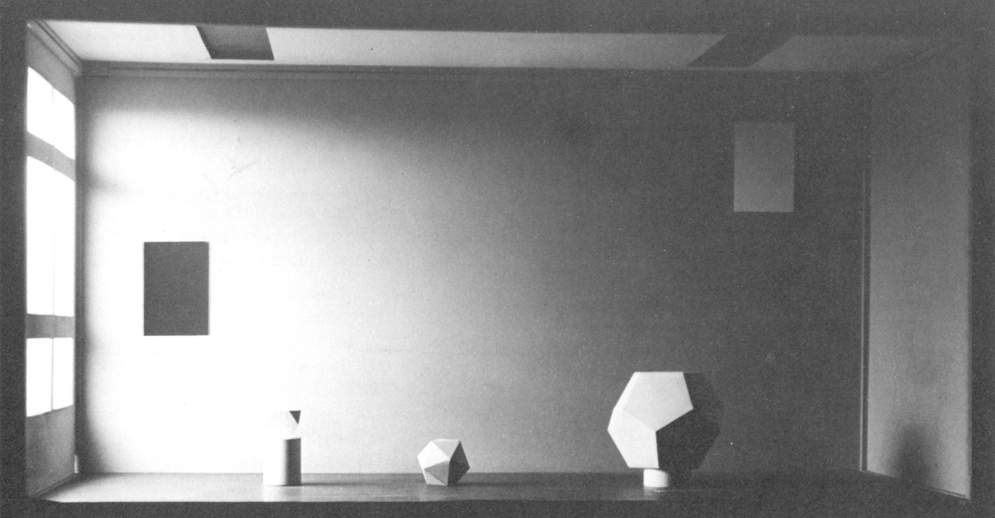
Figure 5-g: light study (from Colour Co-ordination Handbook, 1978)

Daylight, sunlight, moonlight and streetlighting all produce different stimuli when reflected by exterior pigments. The ability of our visual system to adapt to different light levels means that, for most of the day, differences between colours are maintained. Figure 5c demonstrates our ability to identify colours in context and maintain their relative values: both rectangles on the wall reflect the same amount of light but we see the left hand one as darker. However at the extreme levels of lighting there are differences in our perception of colours.

Our vision operates at light levels as low as 10⁻³ lux but we cannot distinguish hues until levels of between 3 and 15 lux are reached depending on the field of vision (Wyszecki and Stiles, 2000). As light levels increase an effect known as the Purkinje shift means that, at twilight, blue objects can appear brighter, more luminous, than during the day. For rural and suburban areas exteriors are often seen in conditions with levels below 15 lux but in urban areas, with street-lighting producing consistent illuminance of 20 lux, this rarely happens and the relative spd of streelighting assumes much more significance.

At the other extreme of illumination a field of vision which contains large differences in illuminance (for example a large number of brightly illuminated white-painted walls with black-painted doors in shadow) can stretch the adaptability of our vision to its extreme and start to cause physical discomfort. Fields of vision which include large areas with high illuminance (for example a clear sky and full sunshine reflecting off a snow-covered landscape) also exceed the capabilities of our visual system causing discomfort and physical damage. Whilst the quantity of light varies across the day and the seasons it is generally (in UK urban areas) within the range that we can adapt to for colour differences.

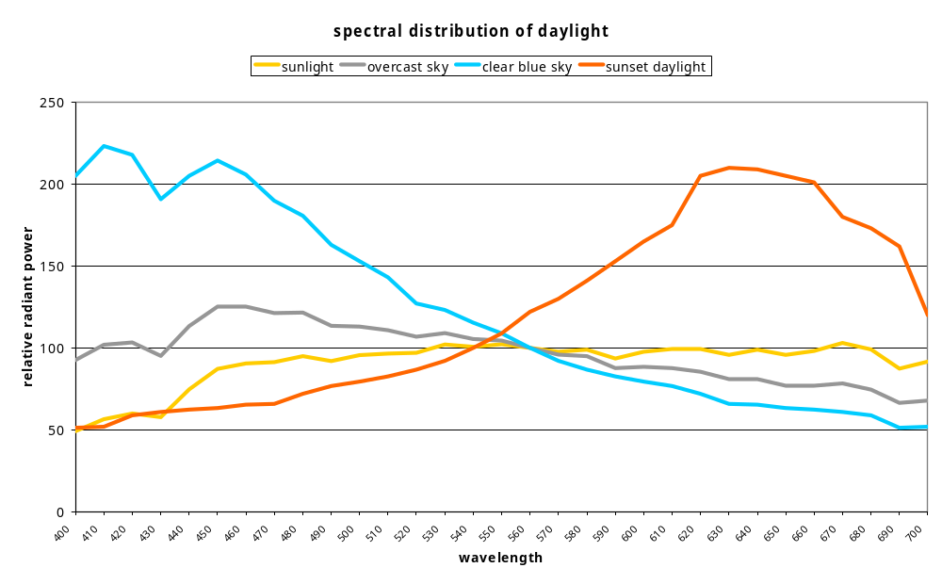
Figure 5-h: spectral power distribution of daylight

The quality of light also varies and this can have significant effects on our perceptions of exterior colours. Some light sources, for example sodium street-lighting, emit light almost exclusively at one wavelength (598nm, yellow) whilst daylight is an ever-changing mixture of wavelengths across the whole visible spectrum and beyond. The amount of atmospheric dust also affects the quality of daylight and it is the scattering of short wavelength light by the atmosphere that produces the blue of a clear sky. As atmospheric dust increases either through pollution or the sun’s angle, longer and longer wavelengths are scattered producing a redder light as well as lower light levels. The difference in the quality of light between regions such as coastal Cornwall (low levels of pollution, frequent clear skies and high levels of reflected light producing high levels of achromatic light outdoors) and urban Glasgow (high levels of pollution, frequent overcast skies and high levels of light absorbed by the built environment producing low levels of light with a bias towards red light) is noticeable. In standard daylight conditions atmospheric dust also produces the tendency for all colours to appear bluer as they move into the distance.

The yellow bias of streetlighting means that, at night and in the evening, blue pigments will appear much darker. There is also a similar effect in urban areas and at sunset where green pigments appear slightly darker.

context
The colour of exterior objects can only be properly assessed in a context which varies in both time and space. The context can include the enormous variety present in vegetation as the image below demonstrates. It can also include local soils; existing buildings; pavement and road surfaces; people; vehicles; snow or rain and the changing colours of the sky. Exterior colour can address some, all or none of the existing context (Linton, 1991).

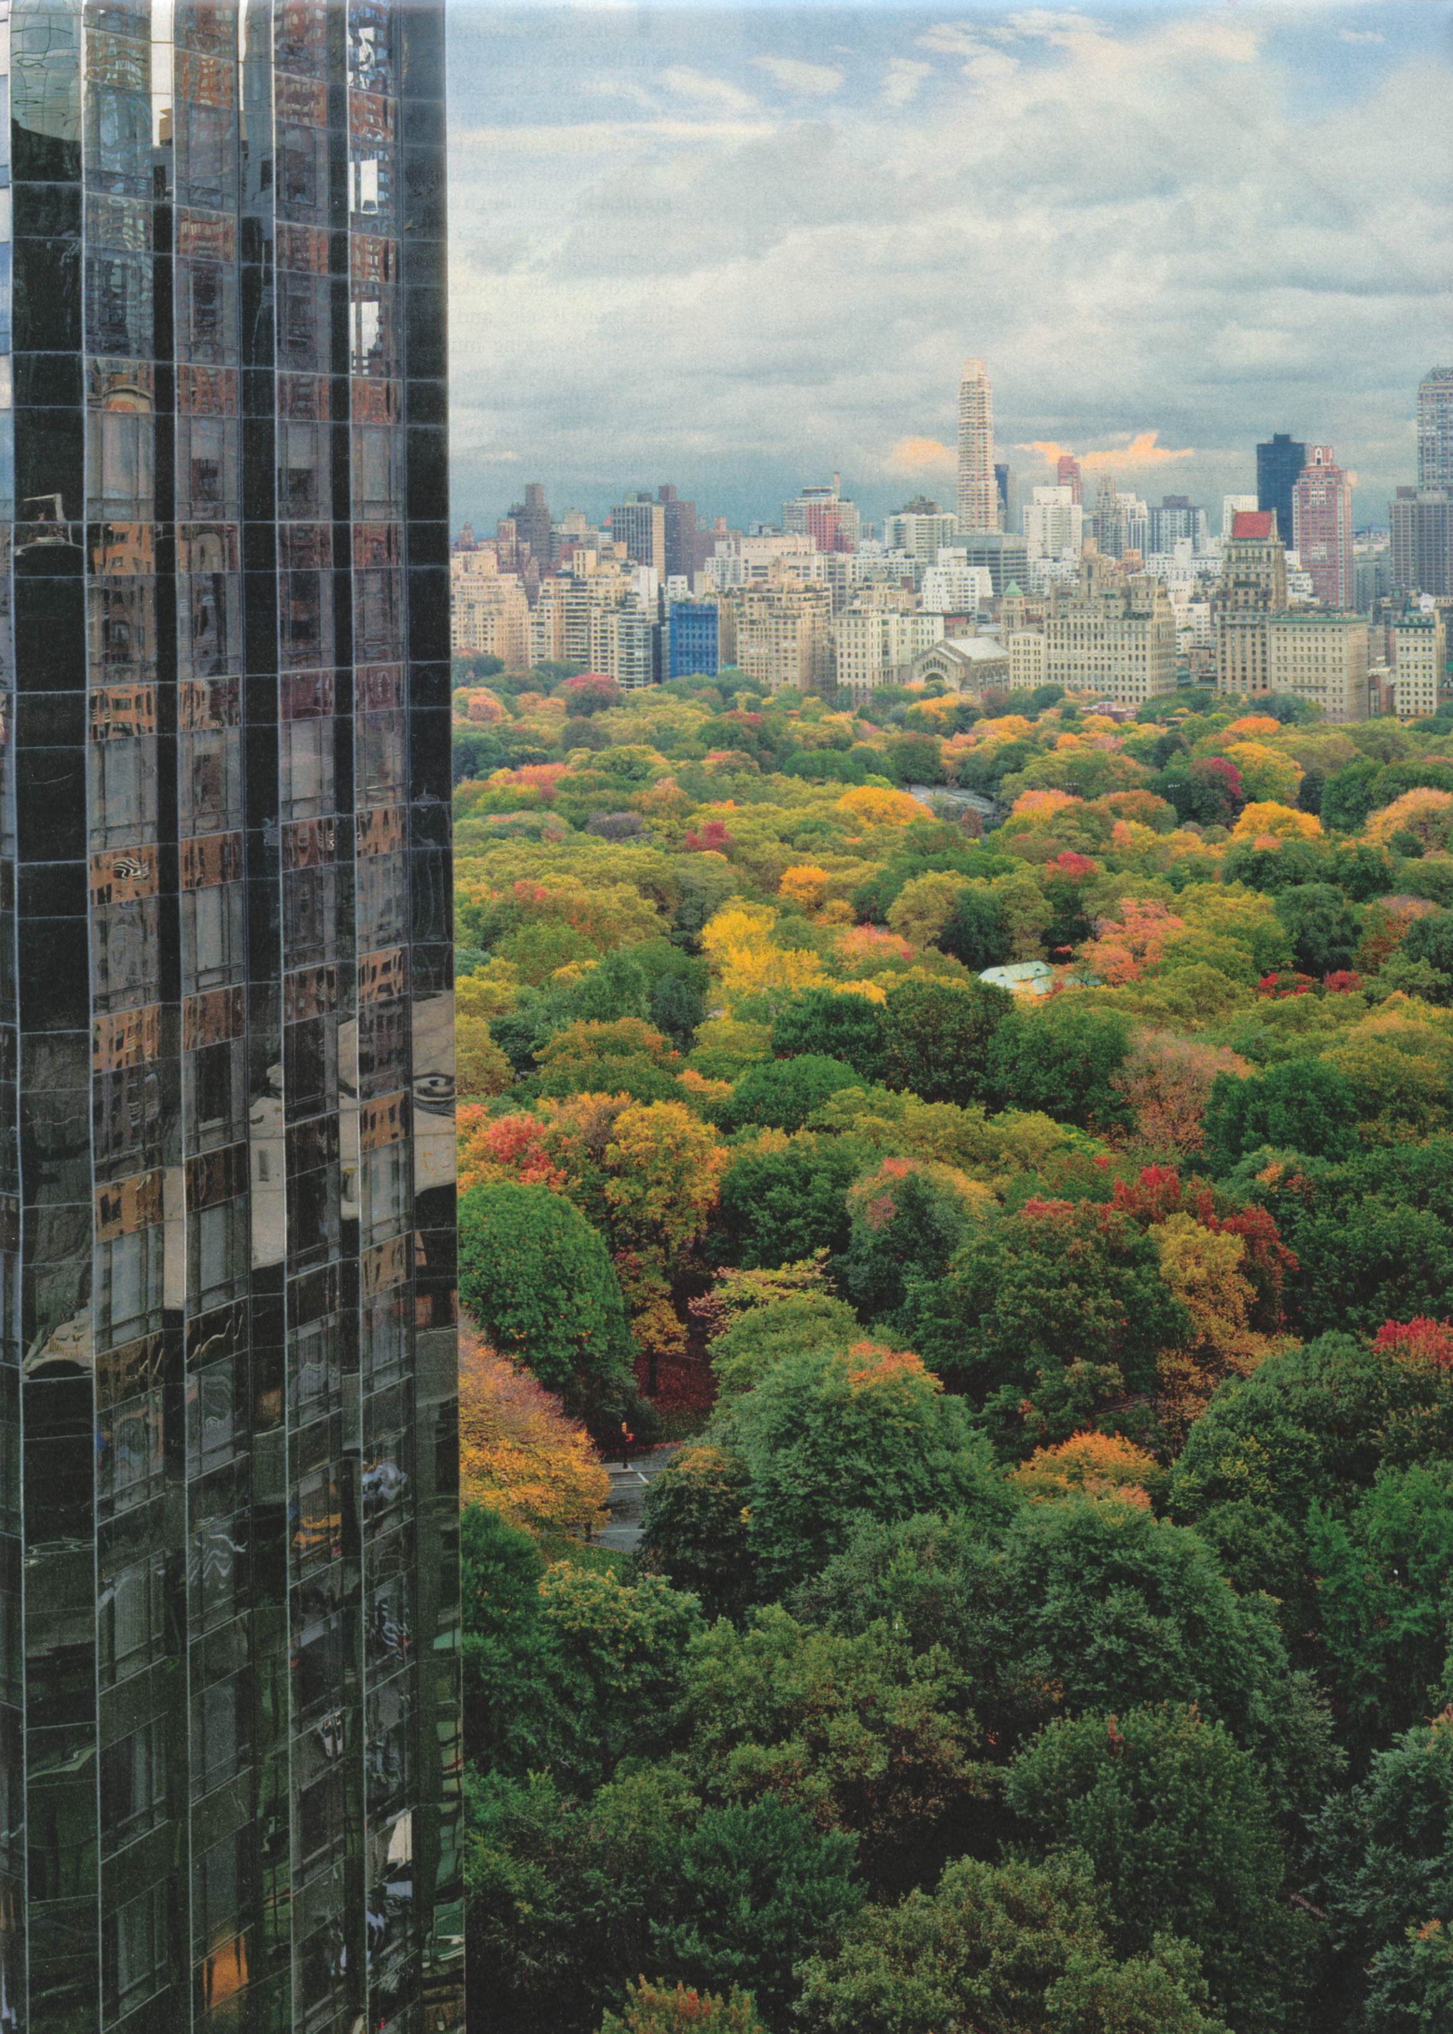
Figure 5-i: Robert Polidori. Central Park (from: Metropolis, 2005)

culture
Colour preferences are influenced by a combination of technology, experience, time and place which we can describe as ‘culture’. It is difficult to generalise about reactions to particular colours or colour combinations and as Lars Sivik has commented “those who are familiar with culture, history and architecture ... often differ from the thinking of the general populace ... they are concerned when the ‘wrong’ colours are applied to old buildings [which] does not seem to upset those who are unfamiliar with art history. The great majority of people are very positive to ‘happier’ colours in the townscape and are extremely critical of the lack of colour” (Porter and Mikellides, 1976: 134). Sivik’s research into attitudes to exterior colour, both in the laboratory with simulated views and using existing exteriors, supported a number of propositions regarding exterior colour:

- some colour feelings (for example: blue is cold, orange is warm, black is serious) are valid in all situations and there is considerable agreement that these hold good over time and across cultures

- some building materials are strongly associated with certain colours (for example brickwork with red) and this influences the perceived suitability of some colours for exterior use

- people can adjust to unusual colours used in exteriors if the colours are seen as appropriate to the materials or if the colours themselves are generally liked (for example although existing blue-coloured housing was liked by residents, pale violet coloured and grey was still strongly disliked)

The colour feelings which Sivik identified as constant are:

heavy | saturated red, orange, blue and violet; all dark colours
light | saturated yellow; all pale colours
open | saturated yellow; pale red, orange
closed | all dark colours
masculine | all dark colours
unusual | all saturated colours
common | pale red, orange
exciting | saturated red, orange, violet; dark red and violet
serious | all dark colours
calming | pale orange
vulgar | saturated red, orange, green, violet; pale green; dark red and violet
ugly | saturated purple, green and violet; all dark colours
beautiful | pale orange
unpleasant | saturated green; pale yellow, green, blue; all dark colours
friendly | saturated orange
warm | saturated red, orange, yellow
cold | saturated green, blue, violet; pale yellow, green, blue; dark blue and violet

colour schemes
An exterior colour scheme can (Gloag and Keyte, 1967):

- introduce an appropriate colour stimulus
- assist good lighting and vision
- express form or breakdown surfaces

The decision about what colour stimulus is appropriate and whether colour should express form or conceal it is one for the designer and the following examples show the effect of different decisions. These examples have been selected either because they demonstrate existing design schemes which are popular with both designers and residents (Burano and Turin) or because they demonstrate different design methods (Chateau Double and Dulux). The schemes are described, evaluated according to the above criteria and also against the rules suggested by Moon and Spencer. The colours of these designs are described in the Windows HSL system (with a range from 0 to 255) and Moon and Spencer’s rules have been translated as follows:

 | variation in value only | variation in saturation only | variation in hue only
pleasing intervals
identity | from zero to 5 | from zero to 10 | from zero to 5
similarity | from 12 to 40 | from 50 to 90 | from 18 to 30
contrast | over 60 | over 120 | from 70 to 128

In order to describe the individual colours and assess the colour combinations, photographs of the townscapes have been opened in Photoshop and colours selected (averaged over a 25 pixel area) from representative areas. Despite co-ordination by the ICC there are obvious errors which this method can produce as images are translated from light to colour film to scanner to digital file to colour monitor. However the ease of use and the fact that this method can be used for both actual and theoretical schemes is why it was selected for this dissertation.

Burano
The most obvious form of colour design for domestic facades is individual. Burano shows that individuals with access to a wide variety of materials and a broad imagination can produce outstanding colour schemes.

The Venetian island of Burano demonstrates a striking departure from the pale colours used across Venice and is a frequently-used example of indigenous vernacular colour. The colours for each house are decided by the residents with the common factors being the use of strongly saturated wall colour, white window surrounds and green shutters. The roofs are universally covered in tiles faded to a variety of warm grey shades. Offers of paint and officially-sanctioned colour schemes from the Soprintendenza di Monumenti have frequently been ignored by the residents who continue to develop their own colour designs (Lancaster, 1996).

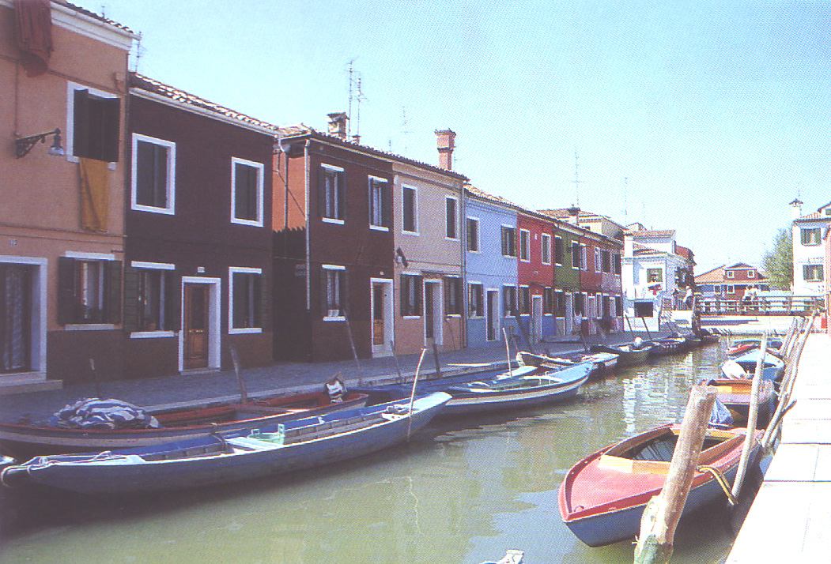
Figure 6-j: Jean-Philippe Lenclos. Burano (from: Les Couleurs de l’Europe, 1995)

The wall colours (from the left of the image in figure 6a) are:

 | H:243  S:119  L:165 | hues are similar; saturations are identical and the difference between values is ambiguous
H:8
S:119
L:120
 | H:8  S:119  L:120 | hues are similar; values are contrasting and the difference between saturations is ambiguous
H:242
S:90
L:204
 | H:242  S:90  L:204 | hues are contrasting; values are identical and the difference between saturations is ambiguous
H:157
S:118
L:196
 | H:157  S:118  L:196 | hues are contrasting; saturations are identical and the difference between values is ambiguous
H:248
S:119
L:120

assessment
In these highly saturated facades all adjacent hues harmonise, occasionally through similarity but frequently through contrast providing a highly-differentiated streetscape. The saturations and values vary and there are ambiguous transformations between adjacent walls. The white window surrounds are achromatic and contrast with the first, second and fifth wall colours but have an ambiguous relationship with the third and fourth wall colours.

The white window surrounds provide cohesion for the streetscape and, although they sometimes contrast and sometimes do not with the wall colours this provides variety rather than confusion. The ordered relationships between adjacent wall colours help to harmonise the street as a whole and, although there are a variety of contrasts, the facade decorations are simple again keeping the streetscape varied rather than confused.

There is no obvious limit to the hues that can be used and, with the walls the only varying element of the facade, each repainting provides the opportunity to adjust the hue according to personal preference and changing tastes and to change the rhythm of the streetscape. The enjoyment of the residents is demonstrated in the existing and continuing choices for individual facades as well as the popularity of Burano streetscapes for visitor’s photographs.

Turin
Turin’s colour design has been recognised as an example of the contemporary reinterpretation of a historic palette (Linton, 1999). From 1850 one colour, Turin yellow, was increasingly used in up to 2000 annual facade repaintings and, by 1970, it had been accepted as in integral part of the city’s identity and specified by the Municipality for the restoration of facades. Research by Giovanni Brino and Franco Rossi of the Turin Polytechnic resurrected the colour plan for the city produced between 1800 and 1850 by the Consiglio degli Edili (Council of Builders) which revealed the polychromatic history of the city. This plan was based on a palette of eight colours, rather than just one, and linked the streets and squares of the city centre into a series of continuous variations around a theme. In 1978 a revised colour plan for Turin was established based on the 19th century colours. The result has highlighted the architectural details of individual buildings and identified specific communities within a coherent whole which is still firmly linked to the city’s history and culture.

The eight colours used in Turin’s restored colour plan are shown below.

1  h: 34  s: 255  l: 128 | 2  h: 0  s: 39  l: 229 | 3  h: 34  s: 255  l: 86 | 4  h: 0  s: 33  l: 198 | 5  h: 23  s: 220  l: 167 | 6  h: 135  s: 72  l: 96 | 7  h: 14  s: 255  l: 91 | 8  h: 17  s: 255  l: 128

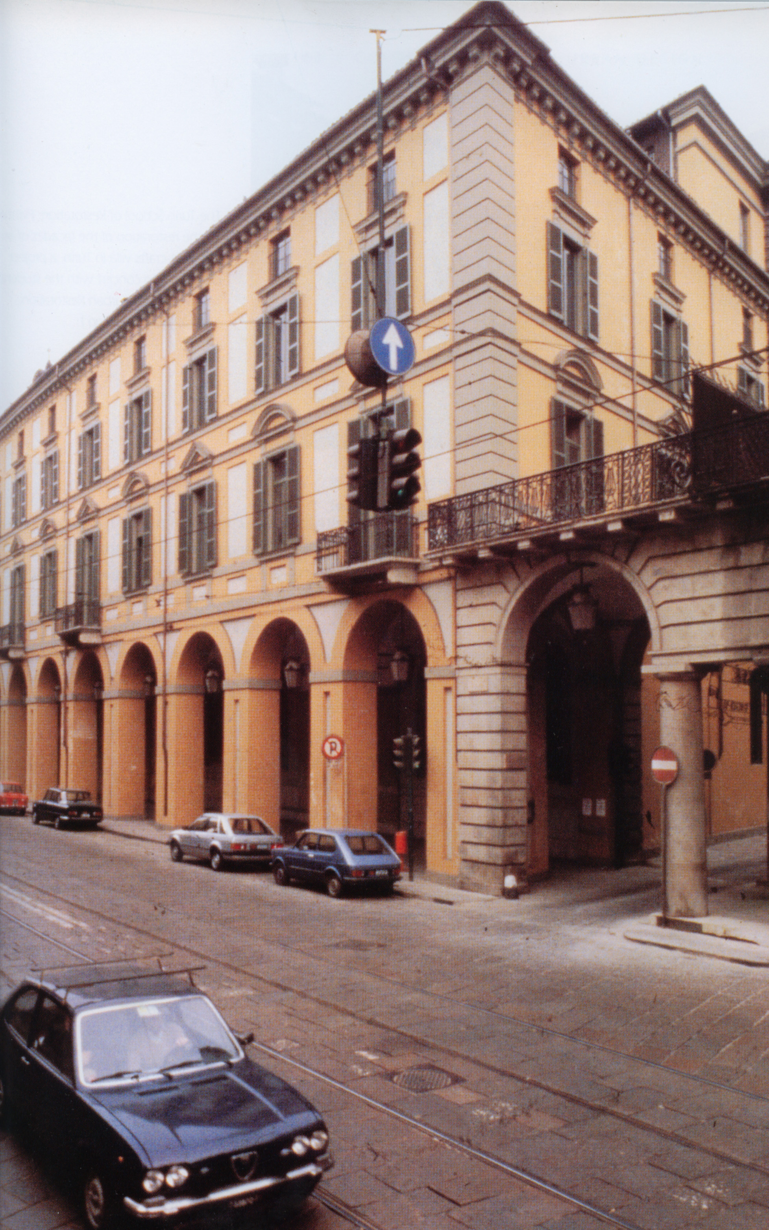
Figure 6-k: Giovanni Brino. Turin (from: Color in Architecture, 1999)

The example in figure 6b uses colours 2, 4 and 5. Colours 2 and 4 are different values of an identical hue – a warm grey – which is similar to the pale orange of colour 5.

assessment
The hues used on this facade are all either identical or similar; the saturation of the two greys is identical whilst their values are similar. the only ambiguous relationship is between the saturation of the darker grey and the orange.

The scheme demonstrates the feasibility of producing individual, and contemporary, combinations using a palette that is limited but still broad enough to allow variation. The eight colours also allow combinations, as above, where there is detailed decoration with different colours (facing wall, end wall, corners, window and arch surrounds) but using similar hues, saturations and values. The relief decoration provides contrast between light and shade.

The limitations of this method of design are that very few areas have a colour plan which was been formally established for long enough to become an established as part of an areas heritage whilst also providing sufficient variety for new developments. This approach also fixes a point in time, in this case 1850, after which new developments in technology are not allowed to enrich the colourscape. The design of individual facades, within the palette, also requires centralised design.

database
Databases have always been used to produce colour schemes: whether formal, such as Colour Index (Krause, 2002) or informal such as the copying of incidental colour combinations in nature. The paint manufacturers Dulux have recently produced an extensive database (www.dulux.co.uk, 2005) to encourage the sale of their interior paints. This combines their library of colours with a series of colour combinations that will, given an initial colour choice, provide a series of harmonising colours based on: different values and saturations of the initial hue; similar hues to the initial colour and contrasting hues to the initial colour, for example:

The initial colour ‘celebration’ was selected. This is matched with the closest colour that is available in a series of varying values (‘salsa melt’ in this case). Three types of harmonies are presented (no matter which colour is selected): six toning colours for a “soft, subtle, understated look”; two harmonising colours (one dark, one pale) to “create a beautiful sympathetic scheme” and one contrasting colour “to accessorise or paint a feature wall to create a scheme that’s refreshingly different”.

starting colour |  | celebration | H:1  S:117  L:111
toning colours |  | salsa melt 1 | H:254  S:94  L:90
toning colours |  | salsa melt 2 | H:253  S:136  L:110
toning colours |  | salsa melt 3 | H:252  S:122  L:121
toning colours |  | salsa melt 4 | H:253  S:114  L:145
toning colours |  | salsa melt 5 | H:0  S:150  L:177
toning colours |  | salsa melt 6 | H:0  S:155  L:184
harmonising colours |  | russian velvet | H:239  S:89  L:120
harmonising colours |  | cuttlebone | H:24  S:95  L:230
contrasting colour |  | jade cluster | H:105  S:91  L:181

assessment
The hues for the toning colours are all identical and both the values and saturations vary in perceptually unequal steps through the series. the difference in value between ‘salsa melt’ 2 and 3 and ‘salsa melt’ 5 and 6 are seen as ambiguous and, in both these cases, the differences between the colours are confusing: large enough to be perceptible but too small to be clearly understood. The hue and value differences between ‘russian velvet’ and ‘celebration’ are ambiguous whilst the hues in ‘cuttlebone’ and ‘celebration’ are similar and the values contrast. Both the hue and value differences between ‘celebration’ and ‘jade cluster’ contrast.

The emphasis is on similar colours but this produces colour schemes with a greater potential for ambiguous combinations as in the salsa melt series and the inclusion of russian velvet.

Chateau-Double
This method for design colour schemes for building facades uses a meticulous assessment of the colours within the location to establish a possible palette for the design. A wide variety of colour combinations using this palette are then produced, assessed and presented.

Jean Philippe Lenclos has produced geographical colour studies of France and the world as well as individual colour facade designs. His design for the facades of 250 apartments, in seven blocks designed by architects Siame and Besson, at Chateau-Double used a palette of 15 principal colours for the apartment walls and 15 secondary colours for planters on the roof terraces. These colours were selected from an examination of the soil of the surrounding area in Aix-en-Provence, suggesting red ochre and yellow ochre as starting points. The colour design was intended to undermine the repetitive and aggressive geometry of the silhouettes by emphasising selected parts within the blocks (Porter, 1982).

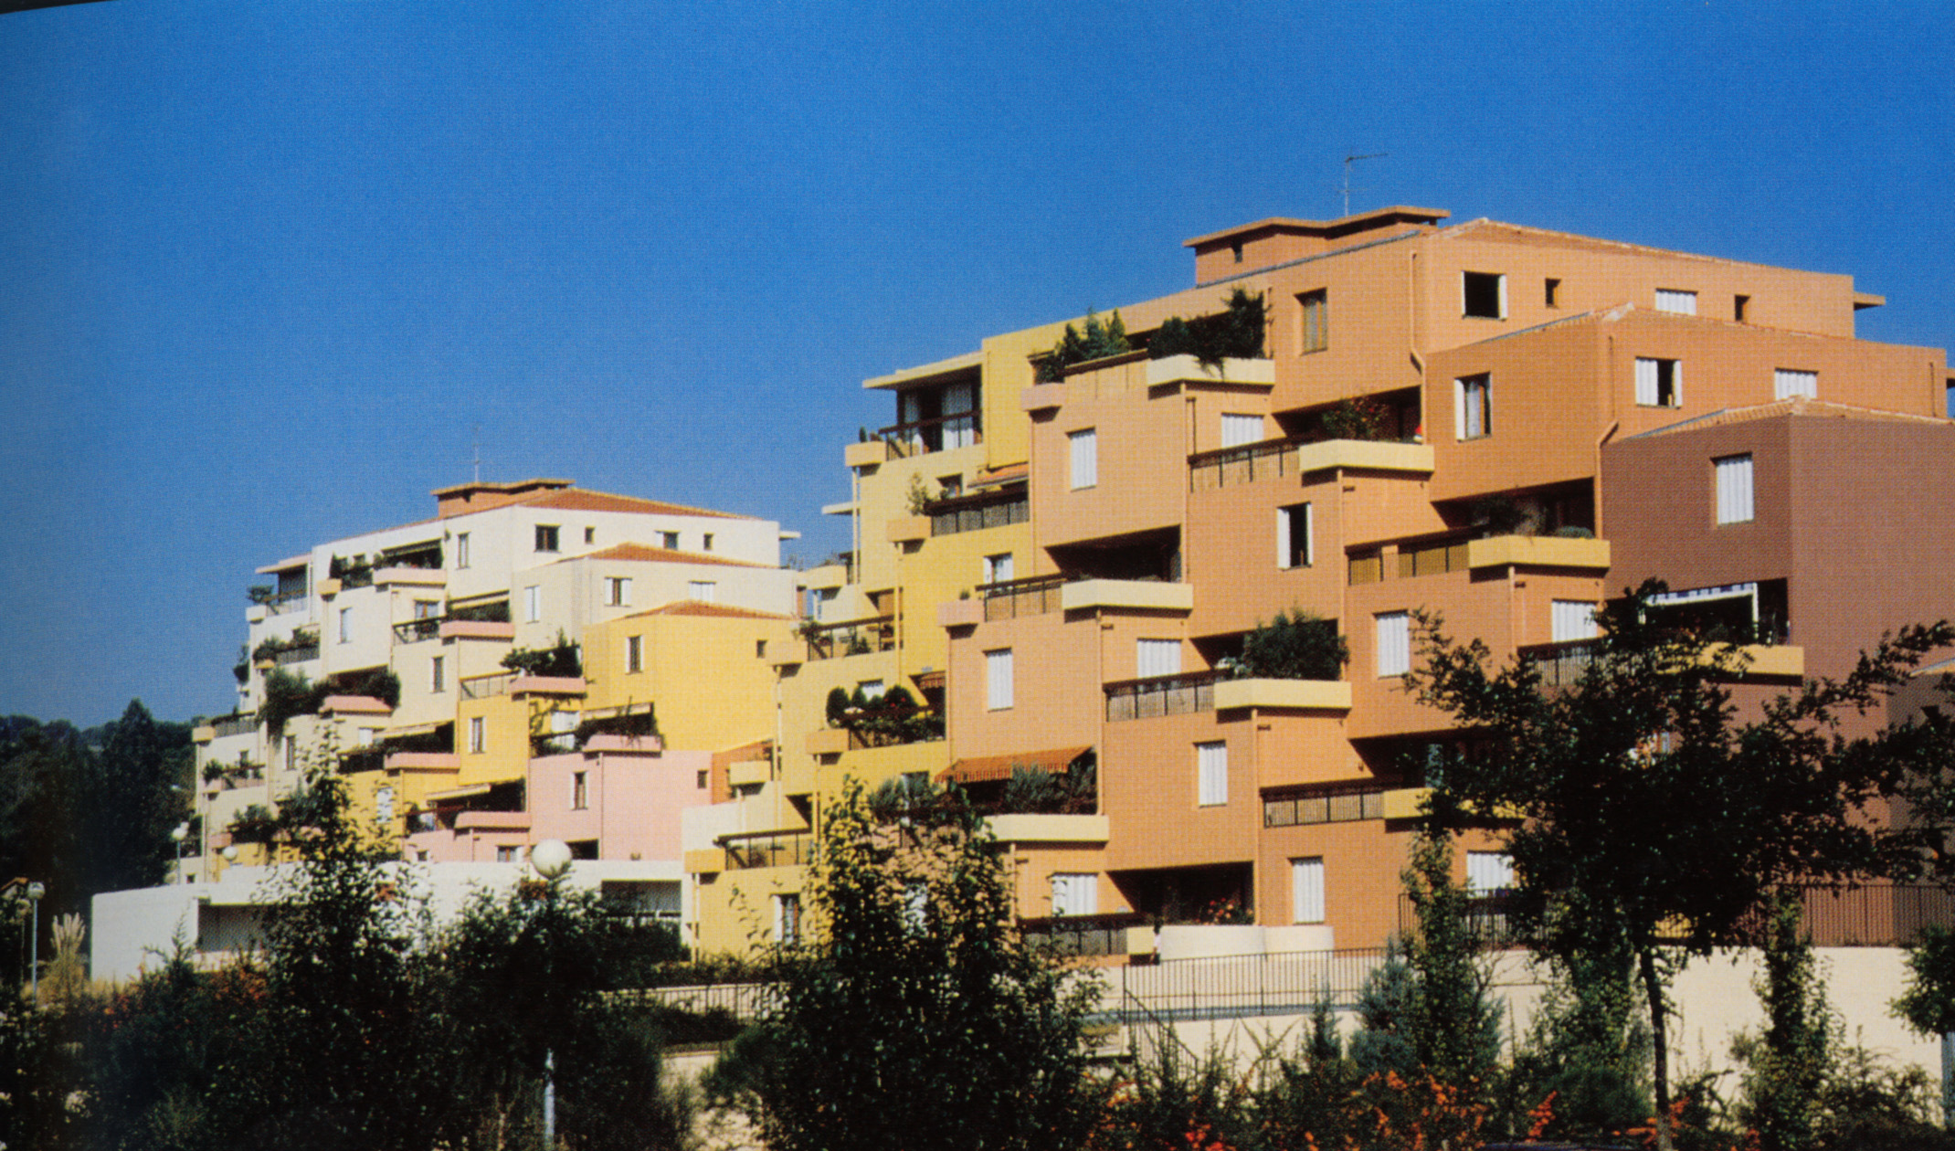
Figure 6-l: Jean-Philippe Lenclos. Chateau Double apartments (from: Colour Outside, 1982)

Two of the completed apartment blocks shown above show the colour varying in a rhythm across the blocks. The colours used in the right-hand block are (from the right of figure 6c):

wall 1 | H:13 / S:88 / L:104
wall 2 | H:20 / S:141 / L:146
wall 2 | balcony 2 | H:26 / S:94 / L:120
wall 3 | balcony 2 | H:26 / S:94 / L:120
wall 3 | H:21 / S:144 / L:156
wall 3 | balcony 3 | H:29 / S:104 / L:167
wall 4 | balcony 3 | H:29 / S:104 / L:167
wall 4 | H:22 / S:135 / L:164
wall 4 | balcony 4 | H:31 / S:92 / L:180
wall 5 | balcony 4 | H:31 / S:92 / L:180
wall 5 | H:29 / S:177 / L:164
wall 6 | H:30 / S:151 / L:174

assessment
The walls vary gradually from a red hue 13 towards yellow, also lightening gradually and with saturation increasing as they move to the left. The changes in hue are barely perceptible each time (the hue of wall 2 is identical to wall 3, wall 3 is identical to wall 4 and wall 5 is identical to wall 6). The changes in saturation and value are also small but these individual shifts produce colours that are similar but subtly, and perceptibly, different. The balconies follow the same rhythm with the hues moving to yellow and lightening as they move to the left but with a different (slightly more yellow, slightly darker) colour as a starting point and with greater increases in lightness, they emphasise the rhythm of the walls. The small, but perceptible, differences in colour differentiate the individual apartments whilst unifying the overall block

The choice of a palette based on the local context is not as limited as the colour plan used in Turin and, like Burano, allows for contemporary colours to be incorporated in the design. It also allows existing colours to be assessed in situ; in changing lights conditions and changing seasons; against the foliage and the traffic of life. The colour variation in material such as stone and earth and foliage also provides a wide range of similar and contrasting hues and values.

The subtle variations in colour are difficult to assess geometrically. Whilst we can perceive, understand and enjoy these colour combinations, the limitations of the metric system is not able to quantify or assess this enjoyment.

colour combinations application

introduction
Rule-based systems are used extensively in colour design to produce colour combinations (QSX, 2005, Gloag and Gold, 1978, Itten, 1987, Logicol, 2000). These systems use variations on the ideas of identity, contrast and similarity and produce colour combinations which are mutually harmonious but there is no evidence of any existing computer-based systems designed for exterior facades. The following application (included on CD as colour combinations.exe in Appendix A) allows the generation of colour combinations in a format applicable to exterior colour: ensuring that all colours respond to the environment; adjacent colours harmonise and colour preferences are allowed for. A specific facade (a terrace of six houses on Great Western Road in Glasgow built as local authority housing in the 1940s but now owned and altered by individual households) was selected to develop this application. This facade (figure 7a) was selected because of its relative complexity (surrounded by foliage and with six separate house walls with individual changes made to each house by the residents); the simplicity of the housing forms; ease of access; its existing monochrome colour scheme (pale grey render) and its similarity to domestic facades across the UK. It is used only as an example to demonstrate the potential of this application.

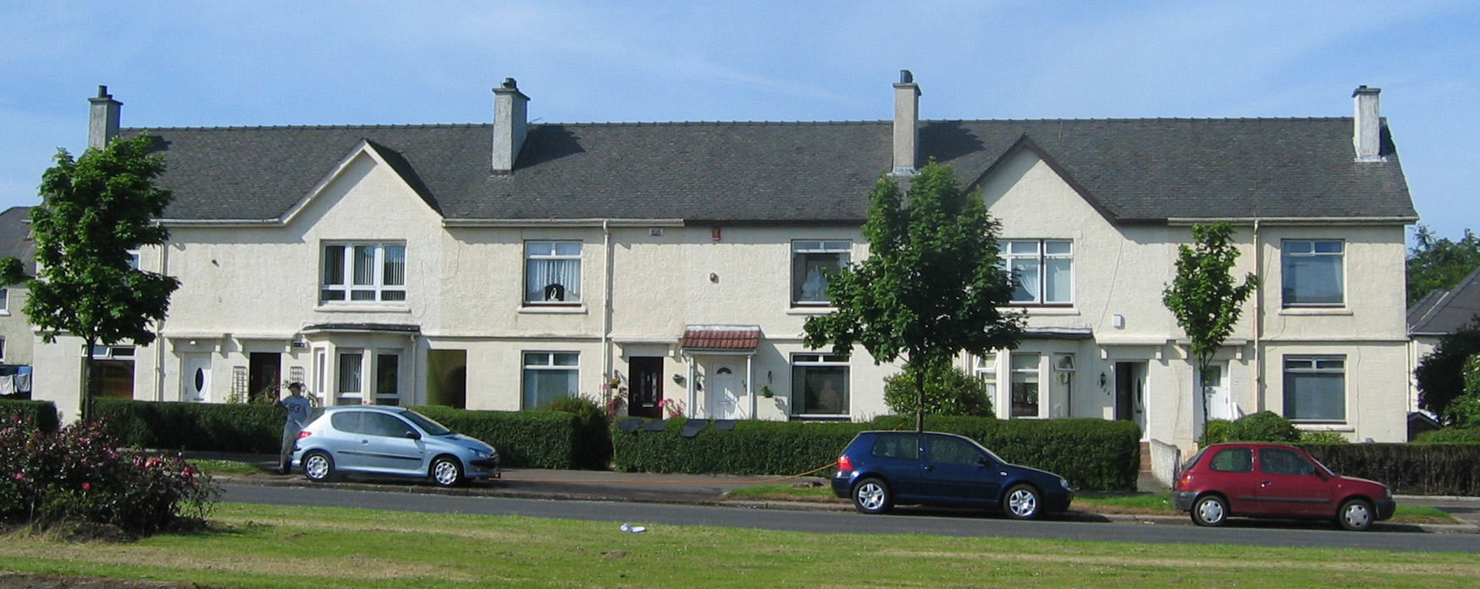
Figure 7-m: Great Western Road, Glasgow

The application has two steps: it selects an initial colour palette and then generates possible combinations from these colours. For example the initial settings on the left in figure 7b will produce the initial colour palette shown on the right and then 568 possible combinations, four of which are shown on the far right.

settings | palette | combinations
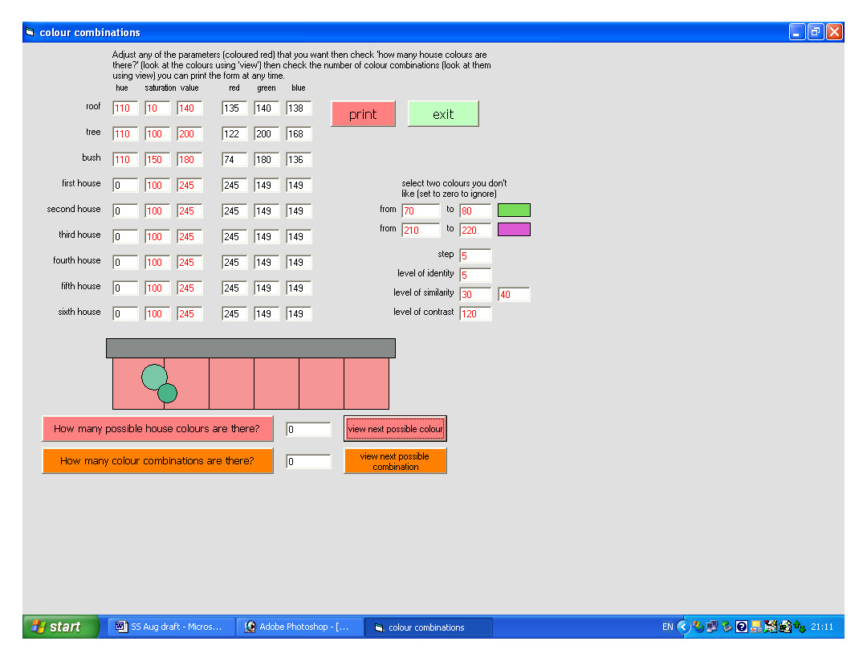  Figure 7-n: examples of colour combination outputs | 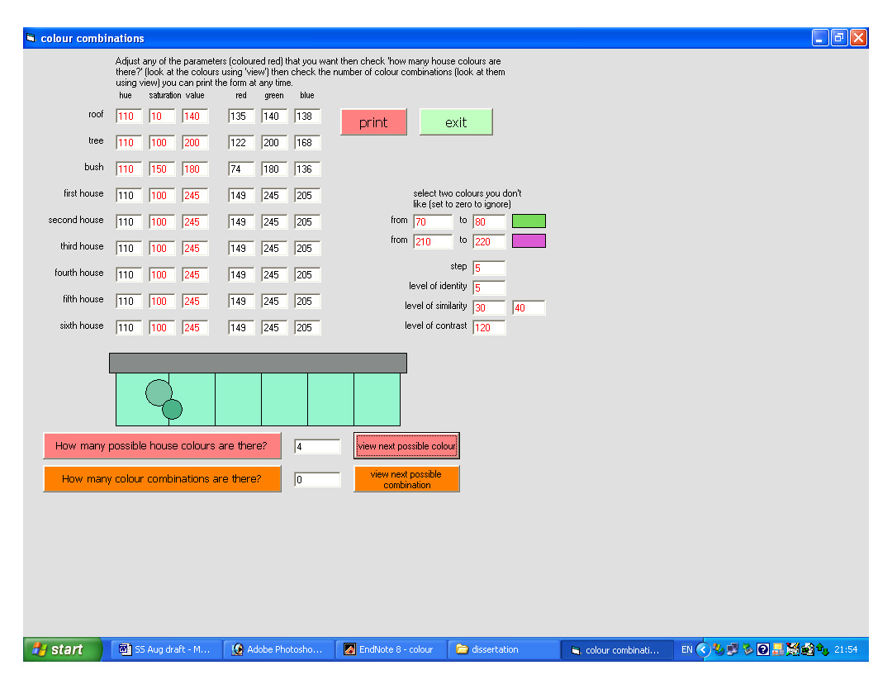 | 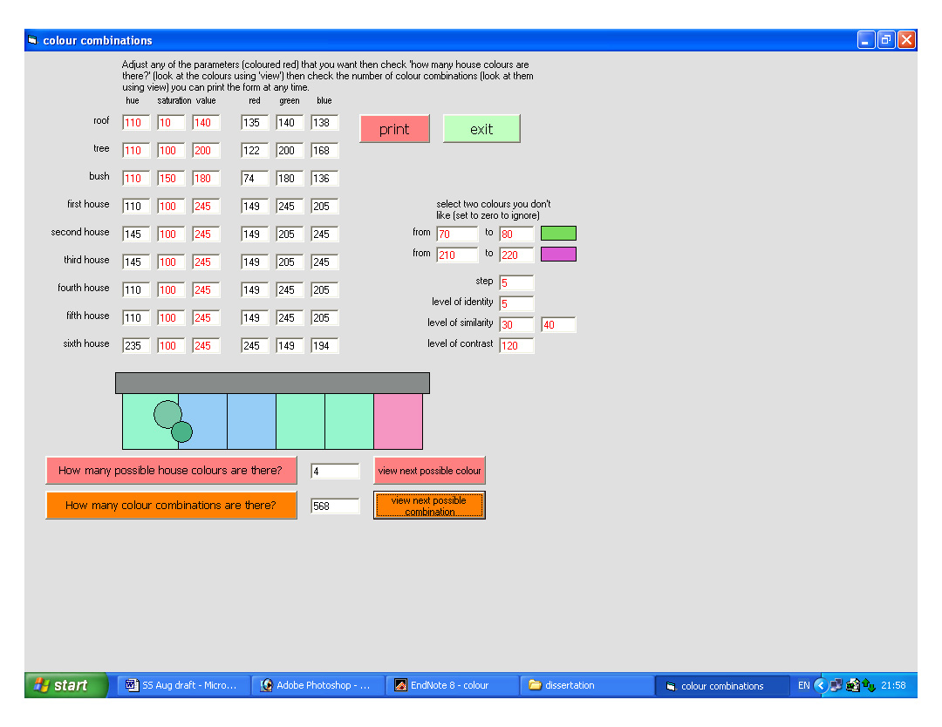
 | 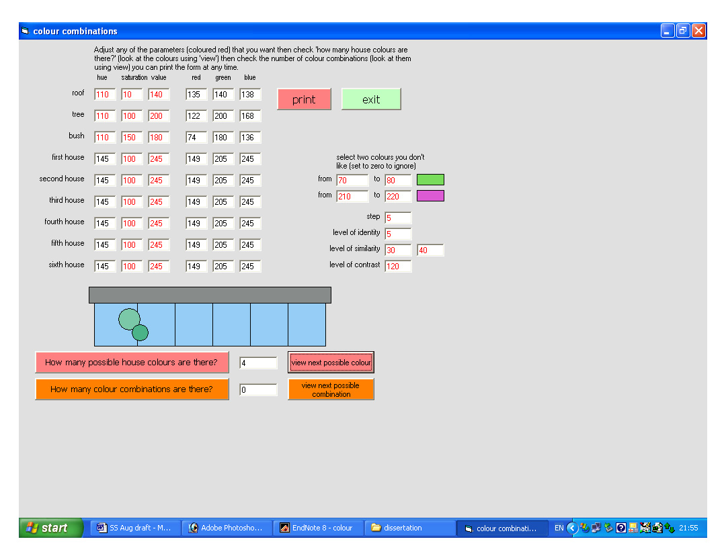 | 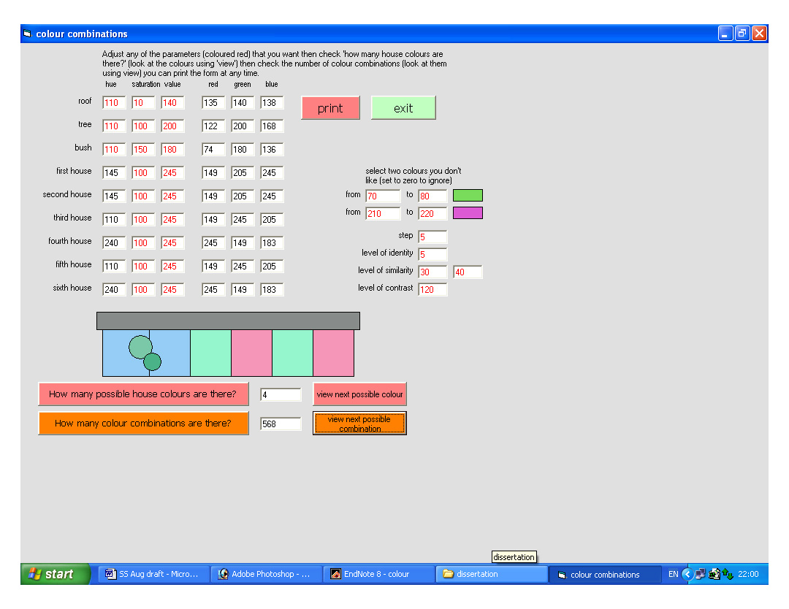
 | 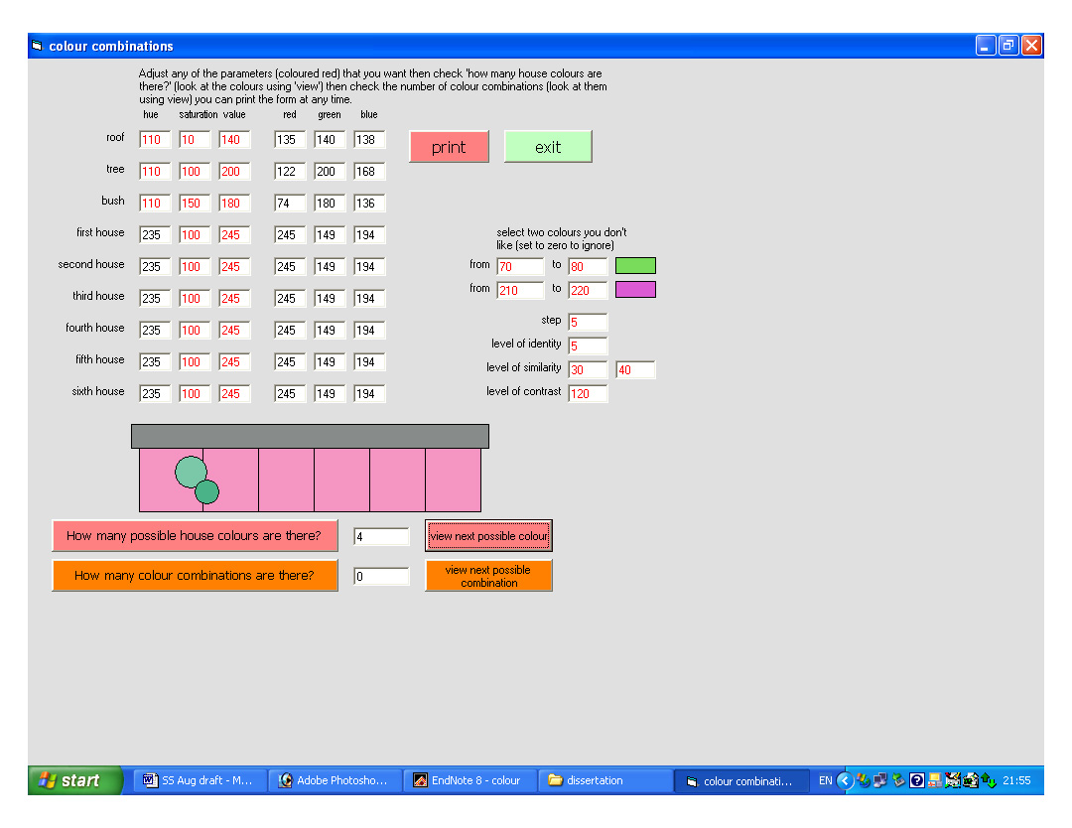 | 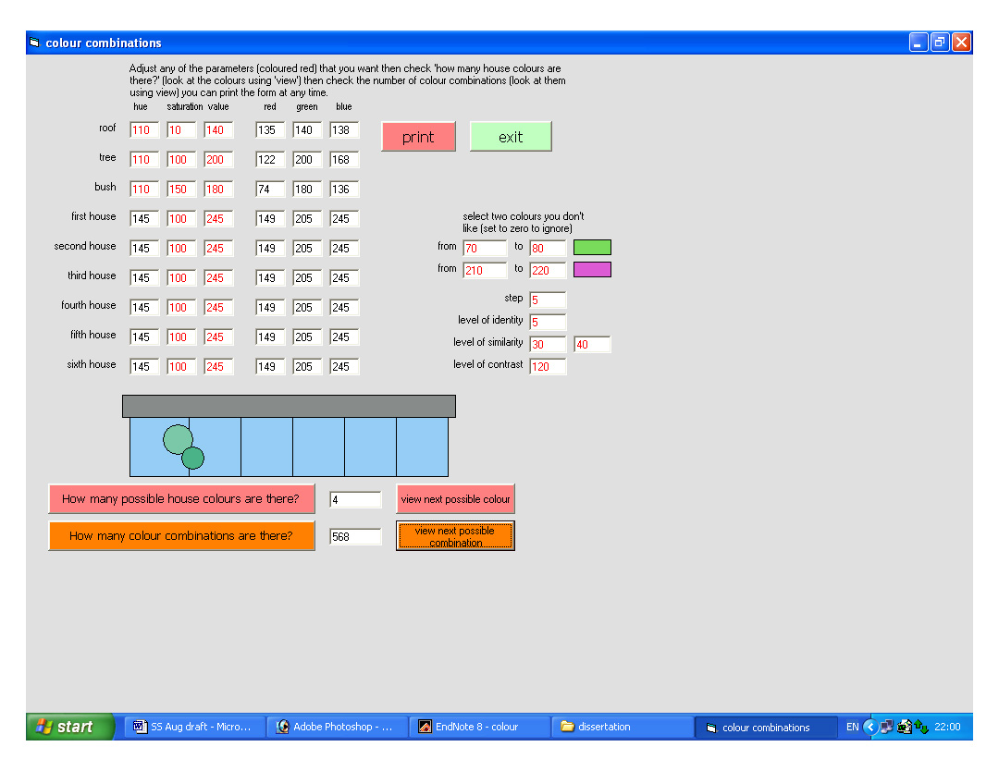
 | 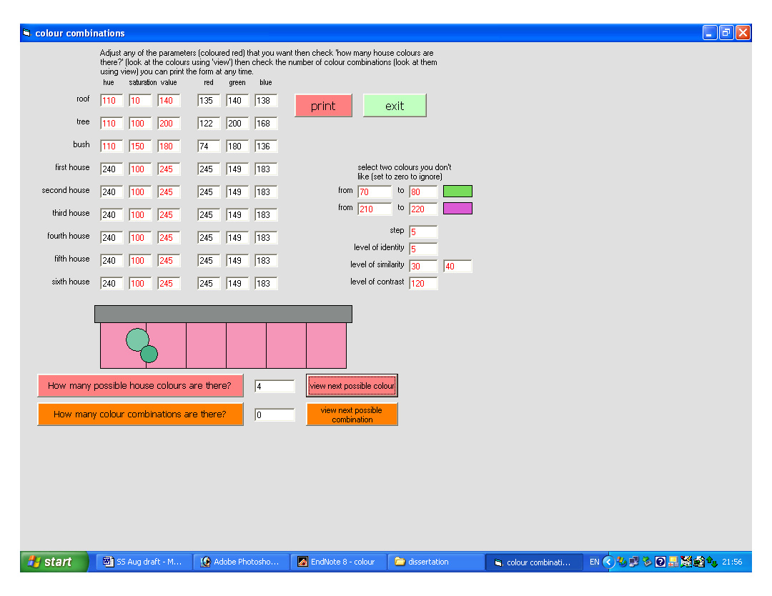 | 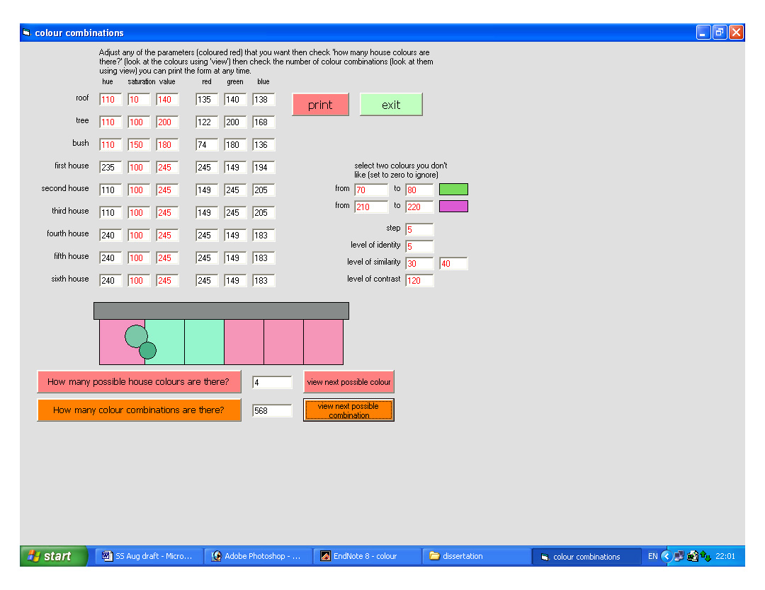

development

colour systems
The analysis of existing exterior colour schemes showed that even in schemes which were acknowledged as successful, such as Burano and Chateau Double, there is no clear relationship between the values and saturations used. Variation in either saturation or value does not appear to conform to any general theory and variation in a combination of saturation and value is difficult to quantify separately through perception (Wyszecki and Stiles, 2000). Since colour is a perceived experience, applying calculations to quantities that have no perceived value is of little practical use. However differences in hue can be perceived separately, even when saturation and value are also varied, and for this reason the application uses geometrical transformations of hue alone to produce colour combinations.

Saturation and value can however be manually altered within the application and will affect the display but are not used for any calculations. For example changing the saturation of houses two, four and six from 100 to 200 and changing the value of houses three, four and five from 245 to 230 produces the same hue combinations shown in figure 7b but (using the second hue combination as an example) the colours have changed as shown.

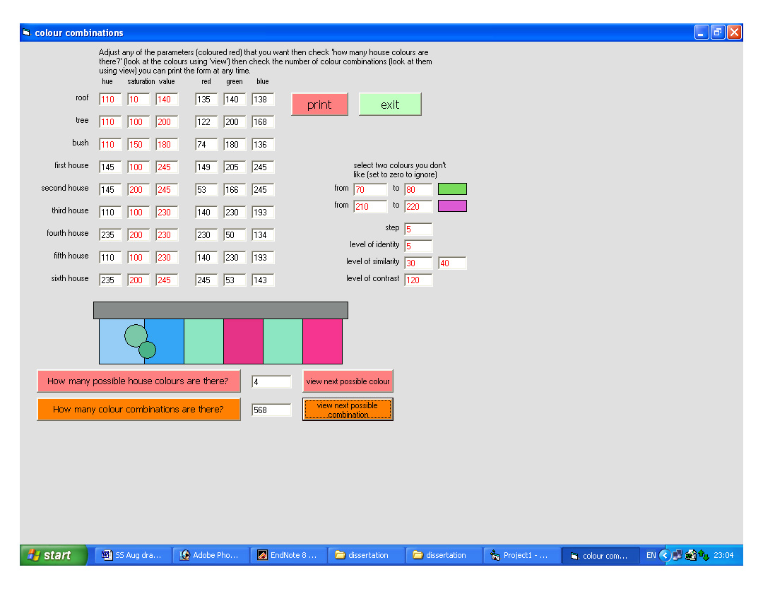
Figure 7-o: varying saturation and value

The application requires colours to be input as a combination of hue, saturation and value all ranging from 0 to 255. These stimuli were selected as the most intuitive way of understanding colour (as opposed to RGB or L*, a and b) and the range used is that of Microsoft applications (the range does not affect any of the calculations and could be changed easily, for example to match a given software application). Although the stimuli of hue, saturation and value are intuitive, describing them in terms of numbers is not and changing the numerical inputs to achieve desired results takes practice. The hue, saturation and value stimuli for each colour are translated into both RGB values and colours on-screen so that combinations can be evaluated and translated into other applications. As the colour wheels in figures 4d and 4e demonstrated the HSV system is inconsistent in the way it reproduces saturation and value and is also biased towards the blue/green region when compared with perceptual systems such as Munsell. Using the HSV system allowed relatively simple calculations to be used in this application but it does mean that colour reproduction is inconsistent and colour contrasts are slightly different from those produced using a perceptual system.

context
The relationship of facade colour to its surrounding environment is one of the key elements of exterior colour design. As figure 5e demonstrates the colours, even in urban areas, are extensive and varied with foliage in particular providing multiple colours across different plants and different seasons. The analysis of a given environment; the selection of elements which the design will respond and the effect which this response aims to produce to has been developed by colour designers such as Jean Pierre Lenclos (Lenclos and Lenclos, 1982). For this application the process has been simplified to limit the environmental colours to two and to allow the nature of the response to these colours to be adjusted as part of the process of selecting an initial palette. The selected facade is surrounded by foliage with both street planting and private gardens, for this reason two foliage elements (‘tree’ and ‘bush’) have been selected although their hues could be adjusted to represent any other two elements in the environment.

colour preferences
There are a number of reasons for colour preferences for exterior colour schemes. Some of these are related to physical qualities, such as light levels, in the exterior environment; some are related to broader colour preferences, demonstrated by Sivik’s research in section 5; some of it is a product of time and place that can be described as fashion and some, such as the idea that “purple undertones are disturbing to a lot of men” (Catinella, 2003), has no obvious cause. The perceptual nature of colour means that there will always be a range of individual preferences and a culture which borders on mysticism has developed around the selection of colours palettes for exterior designs. Colour preferences can be indulged or ignored to achieve desired effects but there are certain hue ranges that should be treated with caution in the selected site.

In the urban site selected the light levels will vary from 70,000 lux on a sunny summer’s day to just 20 lux at night under street lighting. The street lighting used in the selected site is low-pressure sodium lighting which produces light at the wavelength 598nm (yellow). Under this light blue hues will not reflect any light and will appear darker than under full-spectrum light. If the facade is designed to maintain its lightness then blue hues should be used only at low saturations.

In the selected site, as in both urban and rural areas, there is a variety of foliage colours. Any green colour selected for the facade will have an ambiguous relationship with at least some of these colours. As Hardy pointed out in his research into exterior colours across the UK (Porter, 1982) green colours often appear dissonant.

Violet and purple hues are rarely used on exterior buildings in Europe and Sivik’s research noted in section 5 indicates that, although residents have accepted blue hues on domestic facades, violet hues remain unpopular.

The hues green, blue and violet can, of course, be selected for a colour facade to achieve desired effects but the application allows two hue ranges to be excluded from the initial colour palette and green and violet are set as the initial excluded colours. The two ranges can be changed to cover any (or no) hues and the decision to do this will be based on the preferences of the designer and the effect required.

harmony
The application uses three basic ideas of colour harmony (identity, similarity and contrast) which can be adjusted to select an initial palette and then, again, to select possible colour combinations. The initial values are derived from those suggested by Moon and Spencer in 1944.

identity
This form of colour harmony selects hues which are perceived as identical to the original hue. The level is initially set to 5 (from a total hue range of 0 to 255). If it is set to zero then identical hues will not be selected.

similarity
This form of colour harmony selects hues which are unambiguously different from but related to the original hue (for example purple to red). It is initially set to between 30 and 40 (from a hue range of 0 to 255). If it is set to zero then similar hues will not be selected.

contrast
This form of colour harmony will select hues opposite the original hue on the colour wheel (figure 4d) for example yellow to blue. It is initially set to 120 but decreasing this value will increase the range of hues that are considered as contrasting. If it is set to 128 then no contrasting colours will be selected.

number of hues
The step value defines how many colours are tested for harmony. It is initially set to 5 which, out of a possible 255 hues, will test 50 (shown as segments in figure 4d).

examples
Defining the number of hues and environmental colours, excluding specific colour ranges and setting the harmony values are all design decisions that define the specific rules of harmony for the given scheme. Three examples below demonstrates the results when these parameters are adjusted to produce different types of colour scheme.

design for contrast
The first example aims to produce a colourful, contrasting scheme, such as that produced in Burano, which avoids green and purple hues.

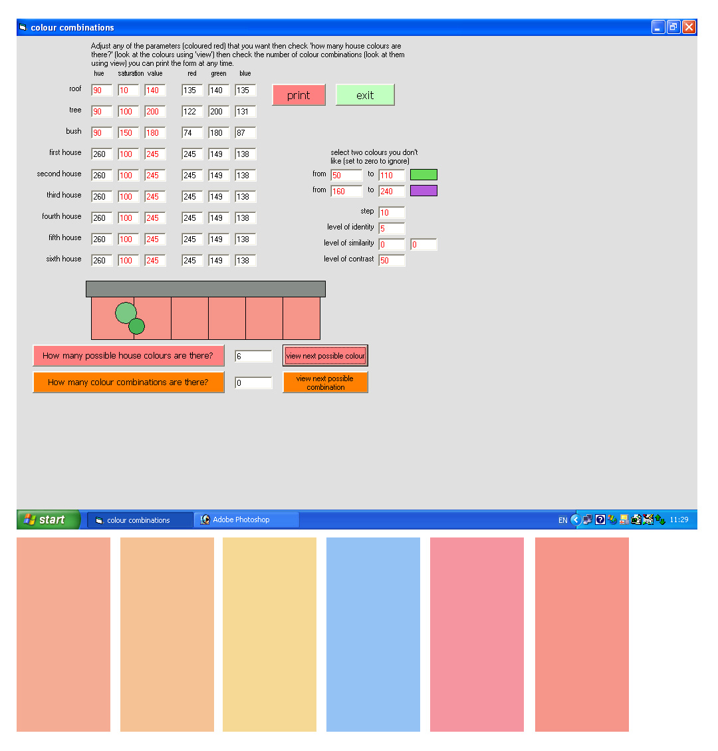
Figure 7-p: initial palette for a contrasting design
Figure 7d shows the settings used to produce an initial palette with the results shown below. The colours are all shown at the initial hue and saturation values of 100 and 245 but can also be viewed by selecting “view individual colours”. Initial settings were as follows:

- the tree and bush hues were both set to 90 (a yellowish green)
- the saturation of the roof was set to zero and the hue to 90 to discount it from calculations
- the hue ranges to be avoided were set to 50 to 110 (greens) and 160 to 240 (violet and purple)
- the step level was set to 10 giving just 8 hues which could be selected (once greens and purples had been avoided)
- the level of identity was left at 5 although since all greens had been excluded the tree and bush colours could not be matched
- the level of similarity was set to 0 so no similar colours could be selected
- the level of contrast was set to 50 so that yellow, blue and red hues could be selected

Once the palette of six colours had been selected the settings were changed to produce combinations as follows:

- the saturation of the individual houses was changed with the strongest colours at the edge of the facade to define the block (the affects the display but not the calculations)
- identity and similarity values were set to zero so that the same or similar colour could not appear on adjacent walls
- the contrast value was changed to 30 (equivalent to a step of at least 42º on the colour wheel shown in figure 4d)

These settings generated 504 possible combinations, one of which was selected and is shown in figure 7e in both the application and translated onto the selected facade.

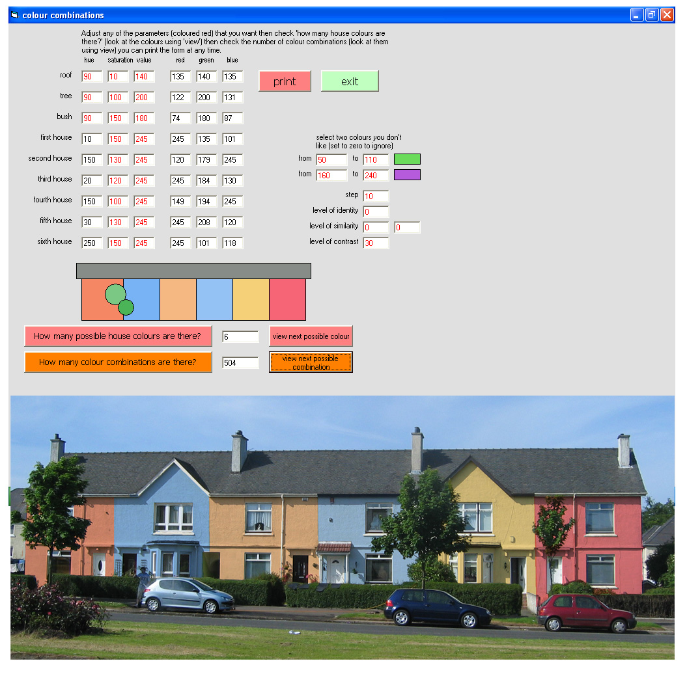
Figure 7-q: contrasting colour combination
The resulting colour scheme, although it uses a very broad definition of contrast, is colourful and dramatic. The large number of possible combinations generated means that individual preferences by householders could also be incorporated whilst maintaining the effect of contrast and without starting the design from scratch again.

design for integration
The second example aims to produce a colour scheme using similar hues, such as that produced in Chateau Double. This time green, blue and purple hues are excluded.
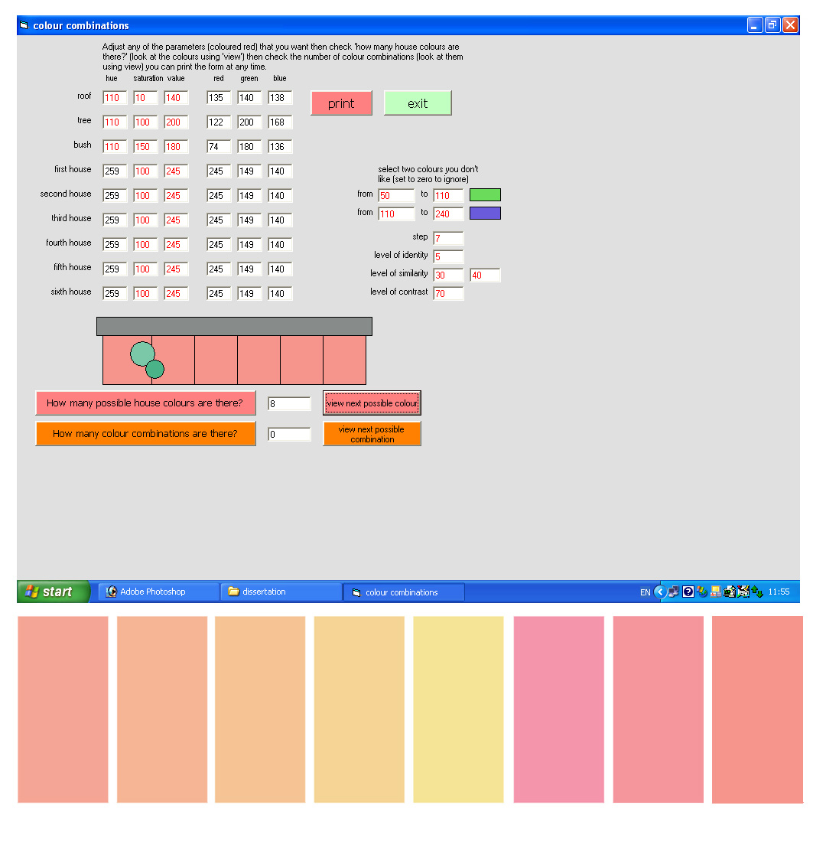
Figure 7-r: initial palette for an integrated design

Figure 7f shows the settings and resulting palette. The settings used were as follows:

- the tree and bush hues were both set to 110 (green)
- the saturation of the roof was set to zero and the hue to 110 to discount it from calculations
- the hue range to be avoided was set to 50 to 240 (green to purple)
- the step level was set to 7 giving 10 hues which could be selected
- the level of identity was left at 5 and the level of similarity was left at 30 to 40 although the colours excluded meant that identical or similar colours could not be selected
- the level of contrast was set to 70 so that red and yellow hues could be selected

Once the initial palette of 8 hues had been selected the setting were changed to generate colour combinations as follows:

- the saturations of the individual houses were changed as in the example above and the values were also changed with values getting lower (and thus darker) towards the edges of the facade

- the level of identity was changed to zero so that identical colours could not appear adjacent to each other

- the level of similarity was changed to range from 20 to 30 (equivalent to a step of between 28º and 42º on the colour wheel in figure 4d)

- the level of contrast was changed to 228 so that contrasting colours could not appear adjacent to each other

These settings generated 104 possible combinations, one of which was selected and is displayed in figure 7g as part of the application and translated onto the selected facade.
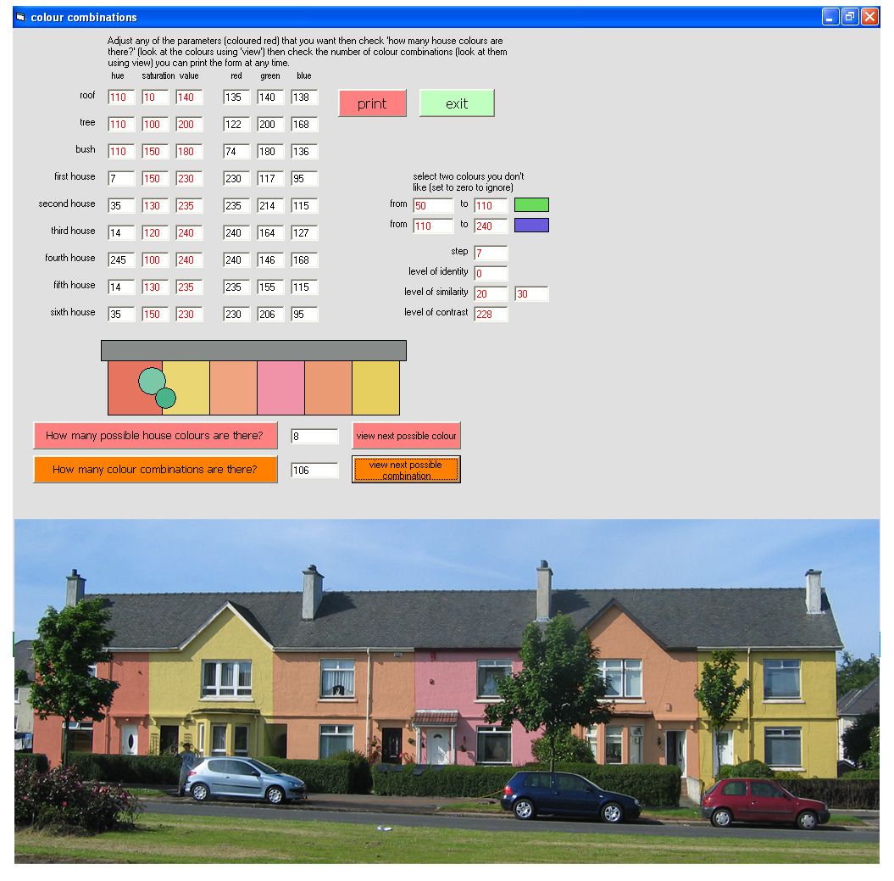
Figure 7-s: integrated colour combination

The resulting design shows a more muted but still varied design. It also shows an asymmetric contrast between the saturation and values of the first and second house which is emphasised by the inconsistencies of the HSV colour system (where yellow hues are consistently lighter than other hues of the same numeric saturation and value). The application produces combinations based on adjacent colours and does not allow patterns to be specified (although they can be selected from the combinations generated) and, although the saturation and value can be manually specified to produce the subtleties of effects in designs such as Chateau Double, the limitations of transforming hues alone is demonstrated in this example. The palette for this design could be limited further by excluding colours such as the pink on the fourth house and contrast could reduced further by changing the similarity value.

design for harmony
The third example aims to produce a colour design which conforms to rules of harmony but includes some green and purple hues.

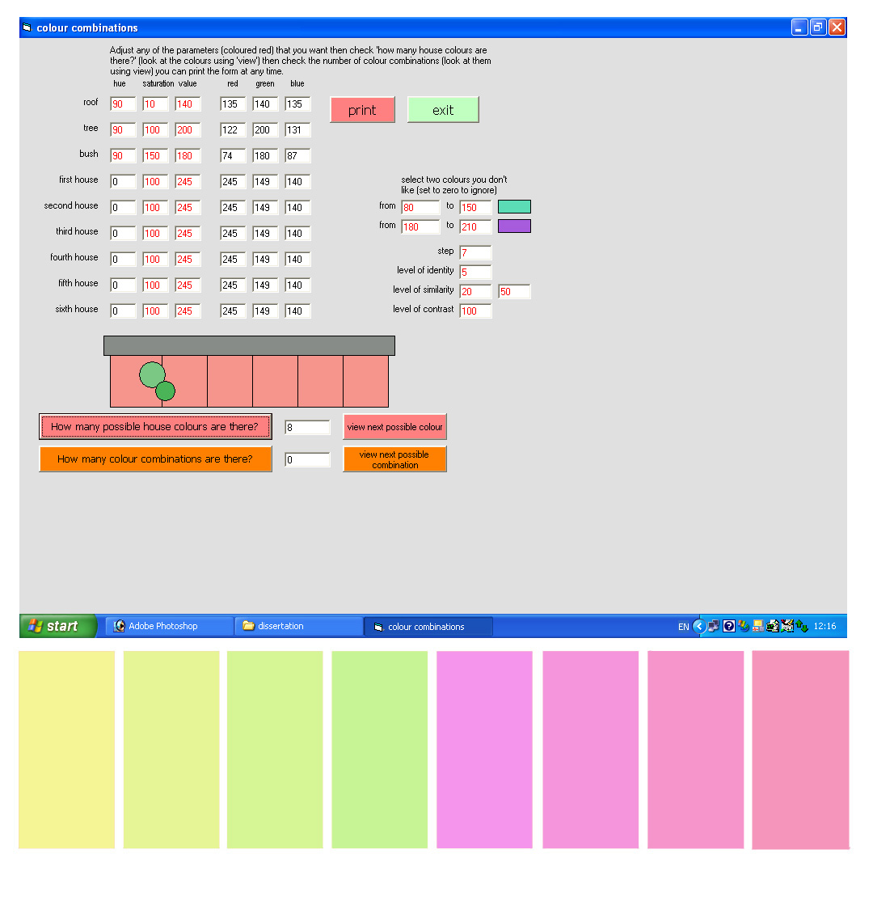
Figure 7-t: initial palette for a harmony design

Figure 7h shows the settings and resulting palette. The settings used were as follows:

- the tree and bush hues were both set to 90 (yellowish green)
- the saturation of the roof was set to zero and the hue to 90 to discount it from calculations
- the hue ranges to be avoided were set to 80 to 150 (green to blue) and 180 to 240 (violet)
- the step level was set to 7 giving 17 hues which could be selected
- the level of identity was left at 5 although the colours excluded meant that identical hues could not be selected
- the level of similarity was set to between 20 and 50
- the level of contrast was set to 100

Once the initial palette of 8 hues had been selected the settings were only changed to adjust the saturations of the individual houses as in the examples above.

These settings generated 42 possible combinations, one of which was selected and is displayed in figure 7i as part of the application and translated onto the selected facade.

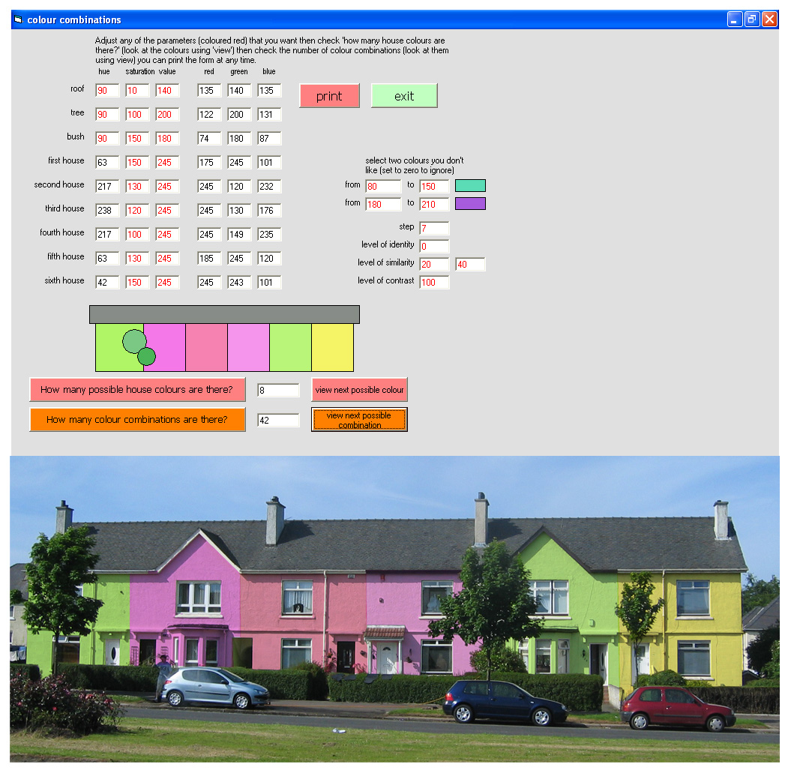
Figure 7-u: harmonious colour combination

The use of greens and purples in the resulting facade is striking and demonstrates the difficulties of using greens on exterior facades, their uniform colour presenting an ambiguous relationship with the surrounding foliage. The use of purples contrasts with the green colours but, as a domestic facade colour, is unexpected. This example demonstrates the importance of selecting or excluding colours for the initial palette which are appropriate to the context.

assessment and development
This application allows the effect of design decisions to be easily viewed and assessed. For a given set of decisions it produces manageable numbers of combinations within which the preferences of a number of individuals could be accommodated.

These examples demonstrate the strengths and weaknesses of this application which, by automating the results of design decisions, can generate possibilities that would take far longer manually, but which is still limited by the decisions taken. Further developments of this application could include:

- allowing colours rather than numbers to be used for inputs

- producing outputs in a format that allows better assessment of the scheme in context

- the flexibility to cover a variety of different forms of facade rather than a single example

- the flexibility to use different elements to establish context or provide unifying colour

- the ability to fix specific colours within a scheme or to limit specific elements to their own palettes

- the ability to specify patterns or rhythms within a colour scheme

- incorporating variation in saturation and value

- incorporating the relative complexity of the design, involving the form and area of design elements

- using a more perceptually accurate colour system than HSV

conclusions
This dissertation set out to examine the nature of exterior colour and to test the possibility of automating some of the elements of colour facade design. The research and subsequent development of a colour combination application has produced the following conclusions.

Exterior colour design, although frequently intuitive, involves a number of varying factors including form, material, context, culture, personal perception and a variety of desired effects. Numerous colour theories have produced harmonious and enjoyable colour designs in a variety of contexts but there is, currently, no general colour theory which is applicable to all situations. Many of the factors affecting colour facade design still require individual assessment and design decisions.

Classical colour theory does provide a framework that can be used to quantify some aspects of colour design. This framework has been tested against existing colour designs and has been found to be true for many simple combinations of different hues. This implies the possibility of automating aspects of the colour design process. New materials and improved pigment technology have increased the possibilities for facade colour to a level where manually processing and assessing all possible combinations is unfeasible.

The development of a software application to assess hue choices and combinations using variable parameters has demonstrated that automation can be used to generate a manageable, but still flexible, number of hue combinations from billions of possible combinations. The automation of this part of the design process still requires qualitative decisions about the parameters used, the combinations selected and the colours (rather than just the hues) within these combinations. It also requires assessment of the combinations produced: sorting the best from the possible.

Colour is a perception which cannot be reduced to physical quantities. Thus colour design can never be a wholly automatic process, it must always include personal choices. However automation, by limiting the possible options to manageable proportions, can increase the choices available to us.

People enjoy both living in colourful surroundings and being able to make choices about their environment. The application developed for this dissertation suggests the possibility of increasing both colour and choice in our surroundings.

bibliography
AGOSTON, G. A. (1987) Colour Theory and its Application in Art and Design, Berlin Heidelberg, Springer-Verlag.
ALBERS, J. (1971) The Interaction of Color, New Haven, Conneticut, Yale University Press.
BERLIN, B. & KAY, P. (1969) Basic Color Terms, Berkeley, University of California.
BIRREN, F. (1969) A Grammar of Color, New York, Von Nostrand Reinhold.
CATINELLA, R. F. (2003) Celia Conover enlivens architecture with some healthy color. Architectural Record.
DULUX (2005) Dulux Paint Solutions.
DUTTMAN, M., SCHMUCK, F. & UHL, J. (1981) Color in Townscape, London, Architectural Press.
GAGE, J. (1993) Colour & Culture, London, Thames & Hudson.
GLOAG, H. & KEYTE, M. J. (1967) Rational aspects of colouring in building interiors. IN HARDY, A. C. (Ed.) Colour in Architecture. London, Leonard Hill.
GLOAG, H. L. & GOLD, M. J. (1978) Colour Co-ordination Handbook, HMSO.
GRANDIS, L. D. (1986) Theory and Use of Colour, Poole, Dorest, Blandford Press.
ITTEN, J. (1987) Colour Star, London, Van Nostrand Reinhold.
KRAUSE, J. (2002) Colour Index, Newton Abbot, Devon, David & Charles.
KUENHI, R. G. (2005) Color - An Introduction to Practice and Principles, New York, Wiley-Interscience.
LANCASTER, M. (1996) Colourscape, London, Academy Editions.
LENCLOS, J.-P. & LENCLOS, D. (2004) Colors of the world
The geography of color, New York, Norton.
LENCLOS, J. P. & LENCLOS, D. (1982) Les Coleurs de la France
Maisons et Paysages, Paris, Editions du Monituer.
LINTON, H. (1991) Color Consultancy, New York, Van Nostrand Reinhold.
LINTON, H. (1999) Color in Architecture, New York, McGraw-Hill.
LOGICOL (2000) EasyRGB-PC Ver. 1.30.
MATTHAEI, R. (1971) Geothe's Colour Theory, London, StudioVista Ltd.
MOON, P. & SPENCER, D. E. (1944) Geometric formulation of classical colour harmony. Journal of the Optical Society of America, 34.
MUNSELL, A. H. (1975) A Color Notation, Baltimore, Munsell Color Company.
PORTER, T. (1982) Architectural Colour
A Design Guide to Using Colour on Buildings, New York, The Whitney Library of Design.
PORTER, T. (1982) Colour Outside, London, Architectural Press.
PORTER, T. & MIKELLIDES, B. (Eds.) (1976) Colour For Architecture, London, Studio Vista.
QSX (2005) Color Wheel Pro. Vancouver.
VON BEZOLD, W. (1876) The Theory of Colour, Boston, Prang & Co.
WYSZECKI, G. & STILES, W. S. (2000) Color Science - Concepts and Methods, Quantitative Data and Formulae, New York, Wiley-Interscience.

